# KBEngine引擎-python脚本应用层

## 1、<Exposed/>属性

<BaseMethods>

<inviteJoinGuild> <Exposed/>  
 <Arg> PLAYER_GBID </Arg>  
</inviteJoinGuild>

</BaseMethods>

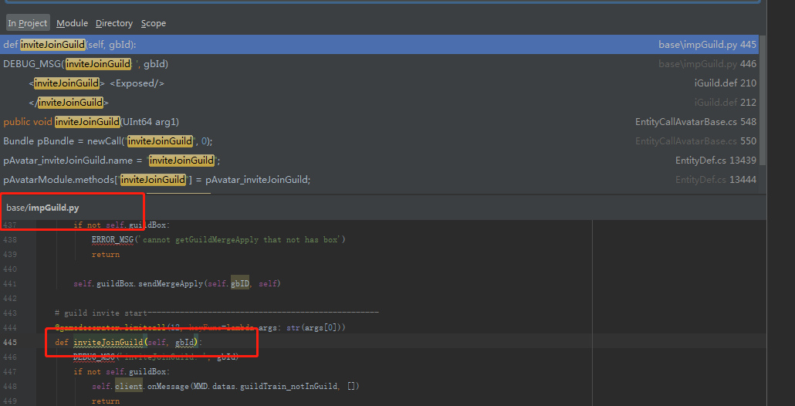

**在base上声明的exposed方法，可以有前端、服务器主动调用，**

**定义的时候，不用写exposed参数**

**服务器主动调用的时候也不用传递实参给形参exposed**

<CellMethods>  
 <enterGuildSpaceToCell> <Exposed/>  
 </enterGuildSpaceToCell>

</CellMethods>

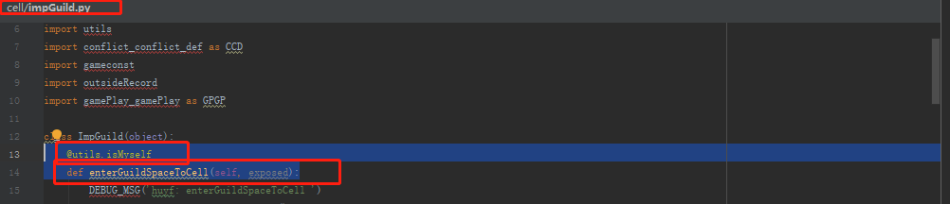

**在cell上声明的exposed方法，可以有前端、服务器主动调用，**

**定义的时候，要写exposed参数**

**服务器主动调用的时候要用传递self.id实参给形参exposed**

.def文件中定义

<CellMethods>  
 <switchPKModel> <Exposed/>  
 <Arg> UINT8 </Arg>  
 </switchPKModel>

**定义处**

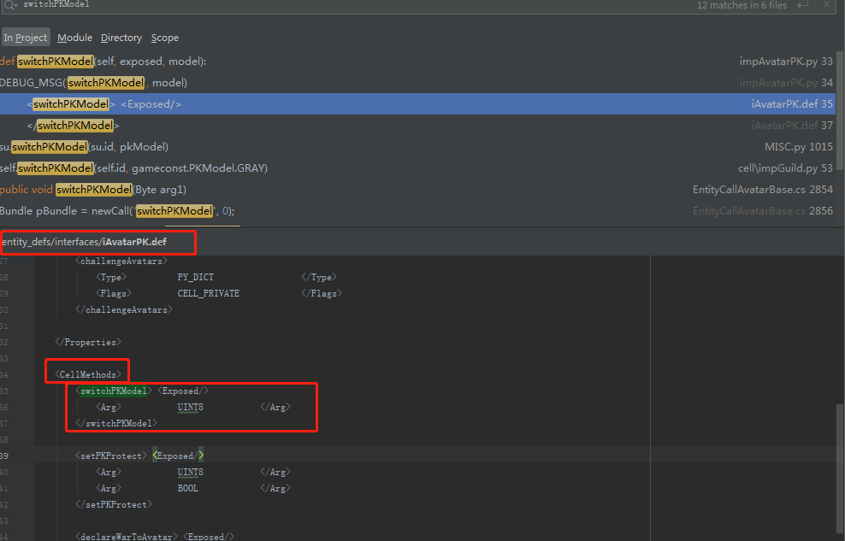

**调用处，cell上需要增加self.id参数。Base上不需要**

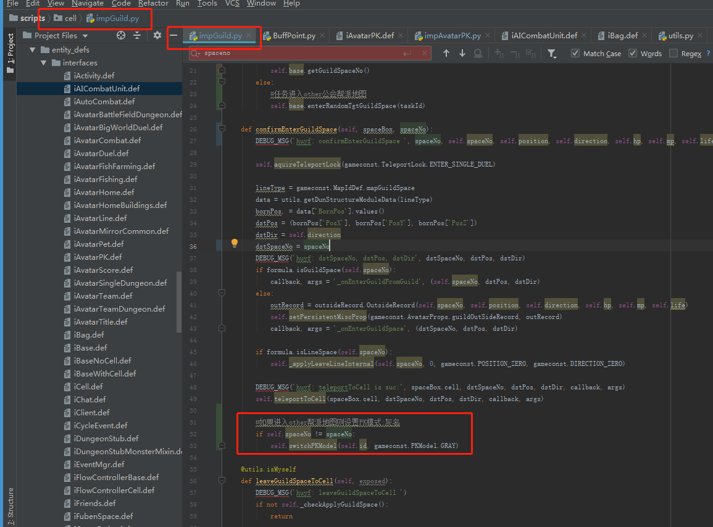

**在base进程上调用cell进程声明的export方法，如果此时调用者是entitycall则不需要增加id参数，如果是avatar对象则需要增加id参数**

[GuildStub(84)]: huyf: enterGuildSpaceToCellByGuildDbId: Cell id:6249, utype:40, component=cellapp[4228002], addr: 192.168.16.155:31752. 128

enterGuildSpaceByGuildUUID Cell id:6249, utype:40, component=cellapp[4228002], addr: 192.168.16.155:31752. 6702561602329575424

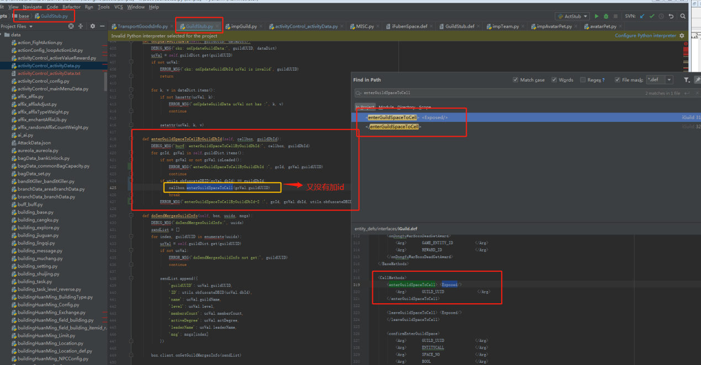

## 2、def类定义文件的注释

<CellMethods>  
 <!--<demoCellMethod>-->  
 <!--<Exposed/>-->  
 <!--<Arg>PLAYER_GBID</Arg>-->  
 <!--<Arg>NUID</Arg>-->  
 <!--</demoCellMethod>-->  
</CellMethods>

<BaseMethods>  
 <!--<demoBaseMethod>-->  
 <!--<Exposed/>-->  
 <!--<Arg>UNICODE</Arg>-->  
 <!--</demoBaseMethod>-->  
</BaseMethods>

## 3、entity的传递和属性访问

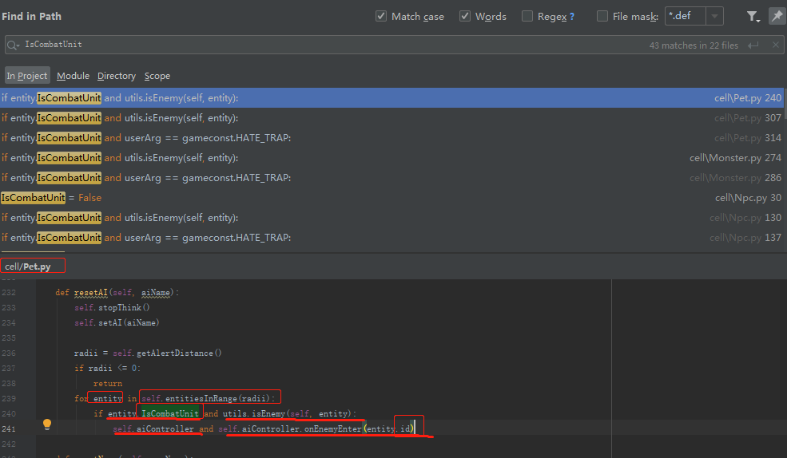

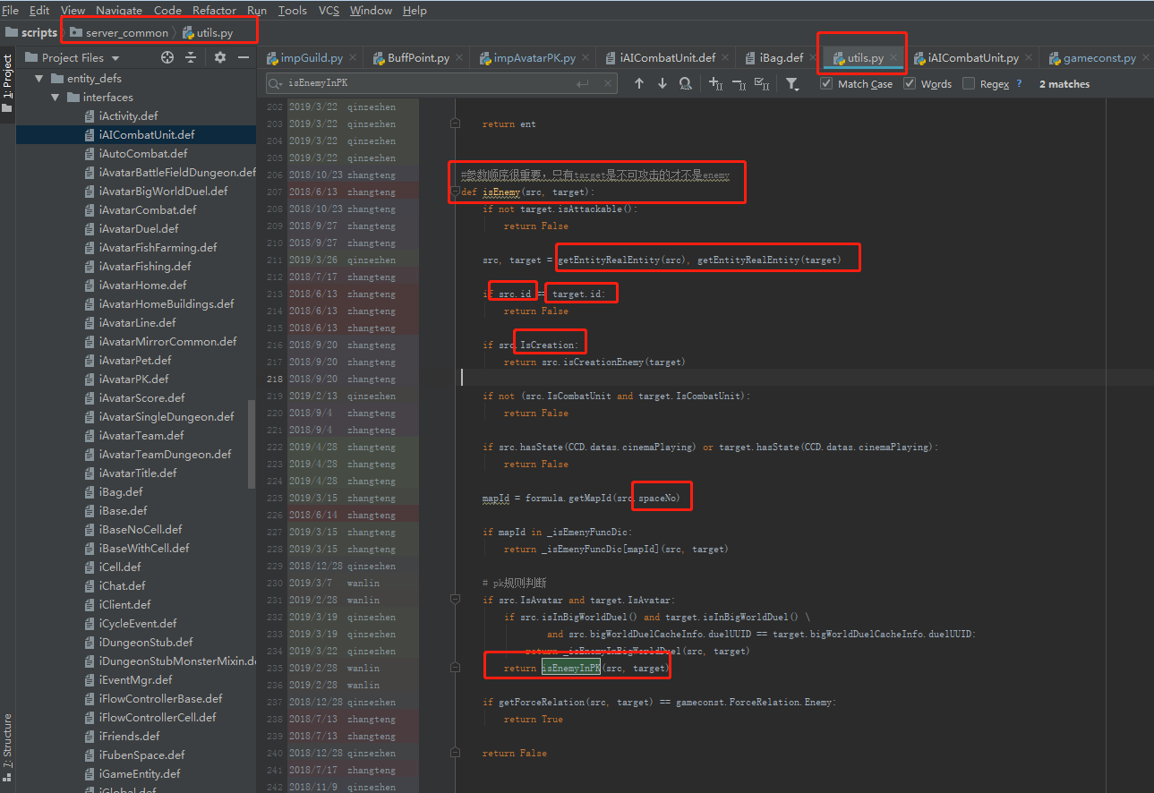

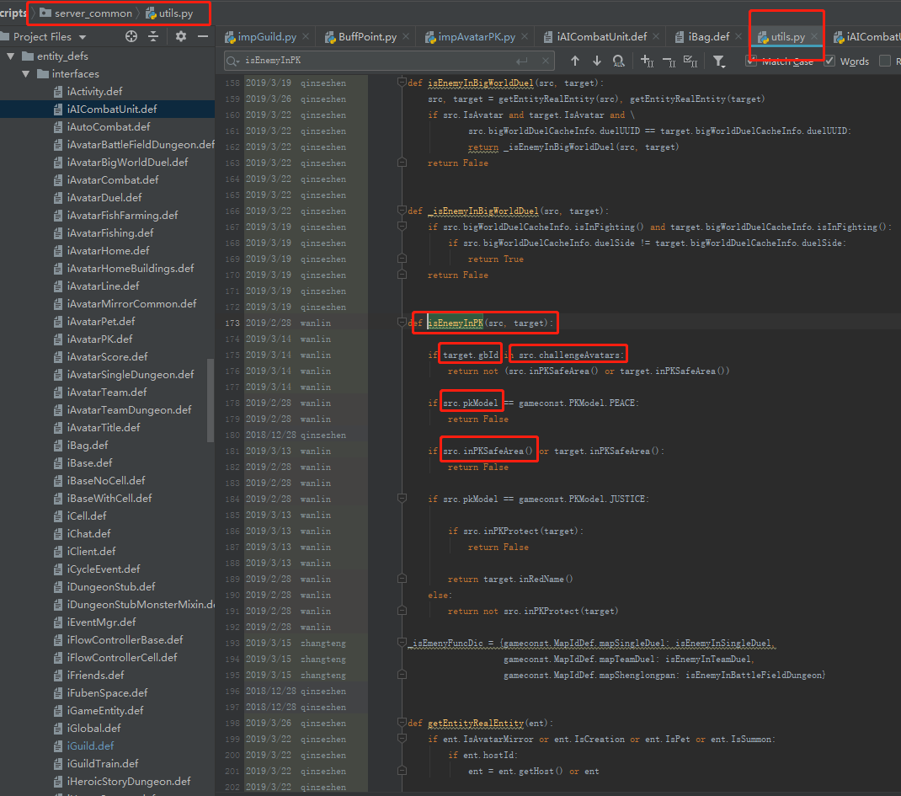

def resetAI(self, aiName):  
 self.stopThink()  
 self.setAI(aiName)  
 radii = self.getAlertDistance()  
 if radii <= 0:  
 return  
 for entity in self.entitiesInRange(radii):  
 if entity.IsCombatUnit and utils.isEnemy(self, entity):  
 self.aiController and self.aiController.onEnemyEnter(entity.id)

#参数顺序很重要，只有target是不可攻击的才不是enemy  
def isEnemy(src, target):  
 if not target.isAttackable():  
 return False  
 src, target = getEntityRealEntity(src), getEntityRealEntity(target)  
 if src.id == target.id:  
 return False  
 if src.IsCreation:  
 return src.isCreationEnemy(target)  
 if not (src.IsCombatUnit and target.IsCombatUnit):  
 return False  
 if src.hasState(CCD.datas.cinemaPlaying) or target.hasState(CCD.datas.cinemaPlaying):  
 return False  
 mapId = formula.getMapId(src.spaceNo)  
 if mapId in _isEmenyFuncDic:  
 return _isEmenyFuncDic[mapId](src, target)  
 # pk规则判断  
 if src.IsAvatar and target.IsAvatar:  
 if src.isInBigWorldDuel() and target.isInBigWorldDuel() \  
 and src.bigWorldDuelCacheInfo.duelUUID == target.bigWorldDuelCacheInfo.duelUUID:  
 return _isEnemyInBigWorldDuel(src, target)  
 return isEnemyInPK(src, target)  
 if getForceRelation(src, target) == gameconst.ForceRelation.Enemy:  
 return True  
 return False

def isEnemyInPK(src, target):  
 if target.gbId in src.challengeAvatars:  
 return not (src.inPKSafeArea() or target.inPKSafeArea())  
 if src.pkModel == gameconst.PKModel.PEACE:  
 return False  
 if src.inPKSafeArea() or target.inPKSafeArea():  
 return False  
 if src.pkModel == gameconst.PKModel.JUSTICE:  
 if src.inPKProtect(target):  
 return False  
 return target.inRedName()  
 else:  
 return not src.inPKProtect(target)

## 4、属性可变类型：如FIXED_DICT、python、dict、list等

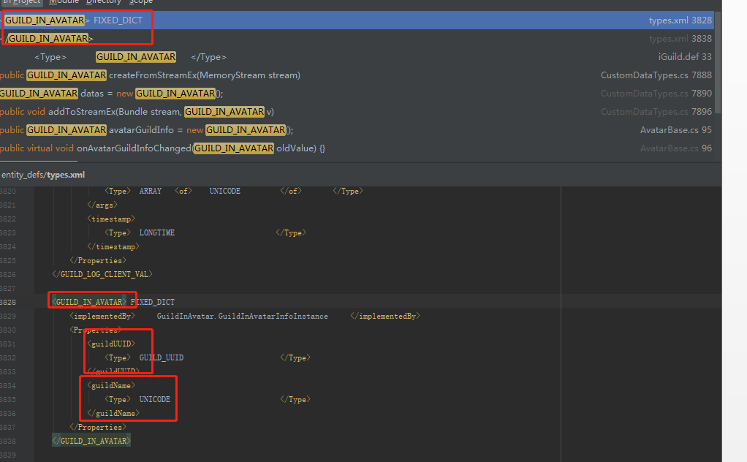

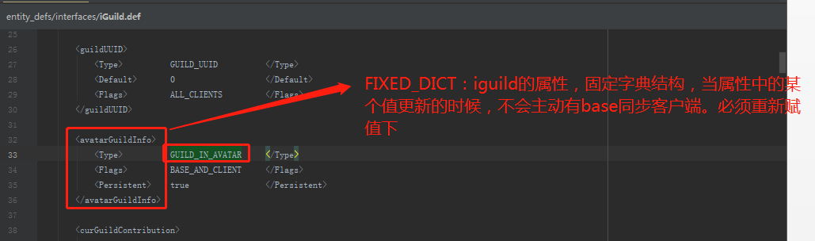

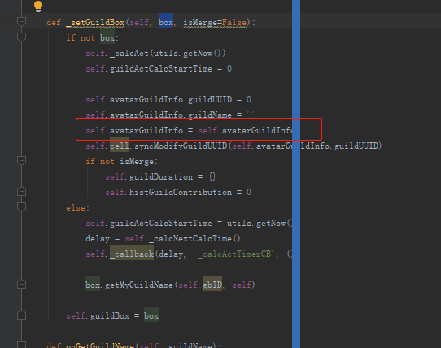

## 5、普通对象的传递（类似guild类对象）可以透传到cell和base进程，参数类型entitycall，可以跨进程调用方法

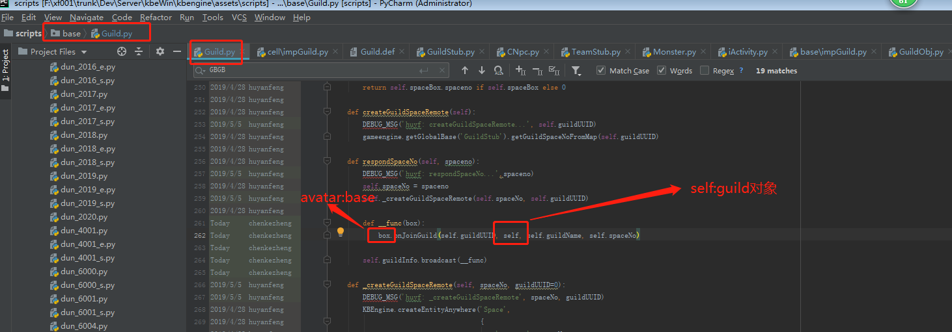

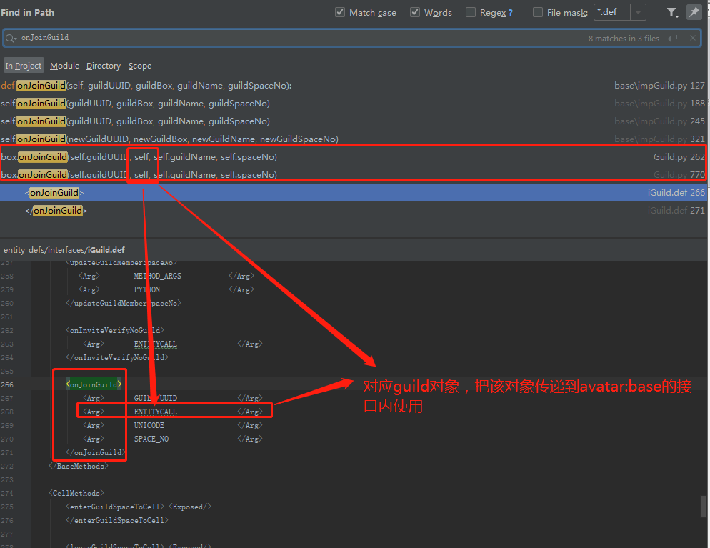

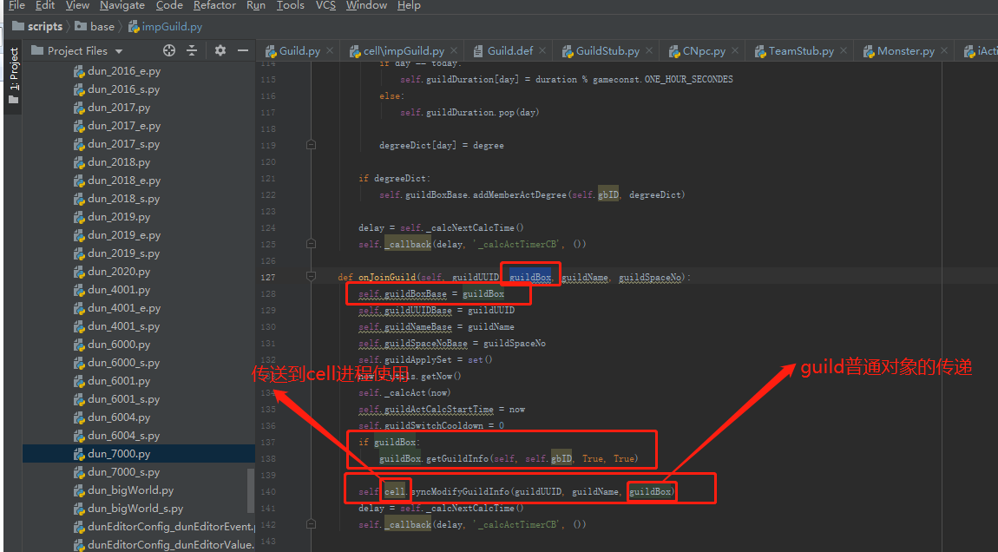

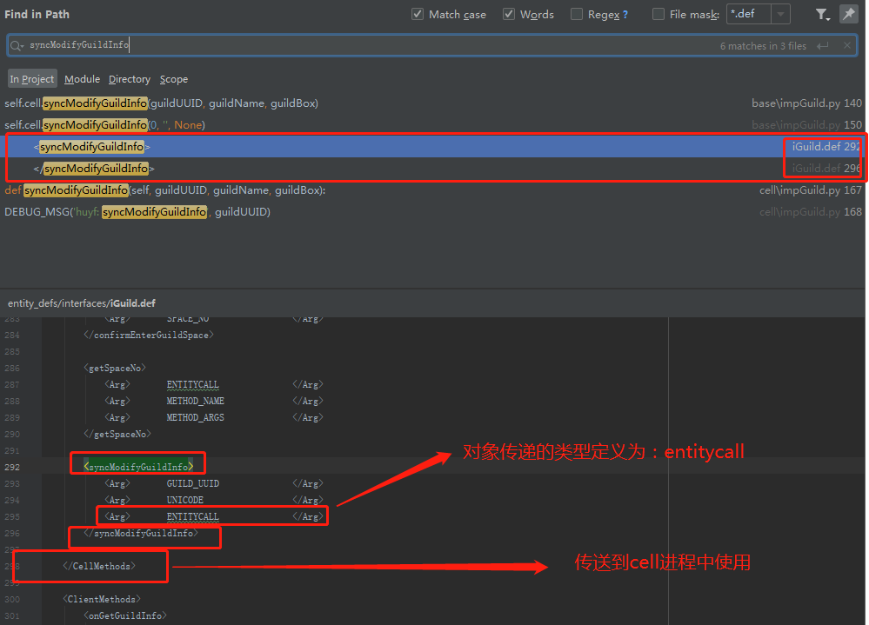

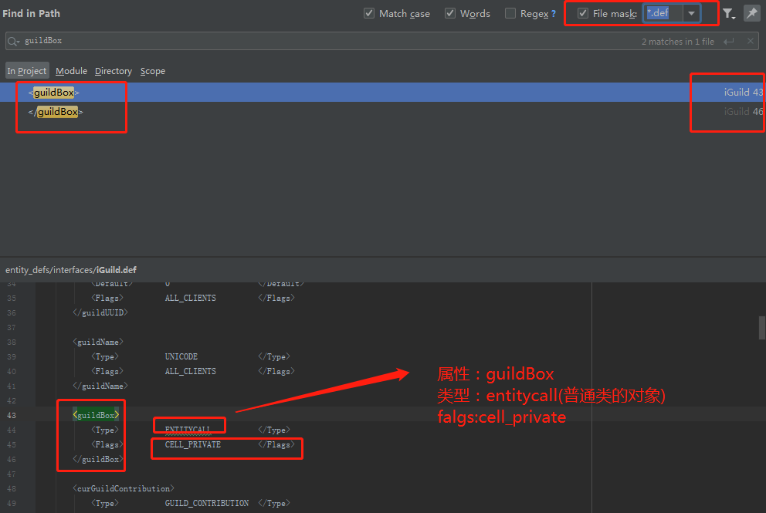

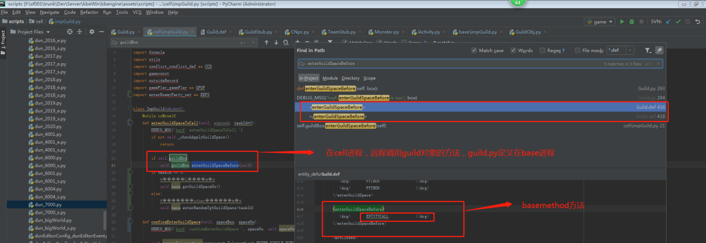

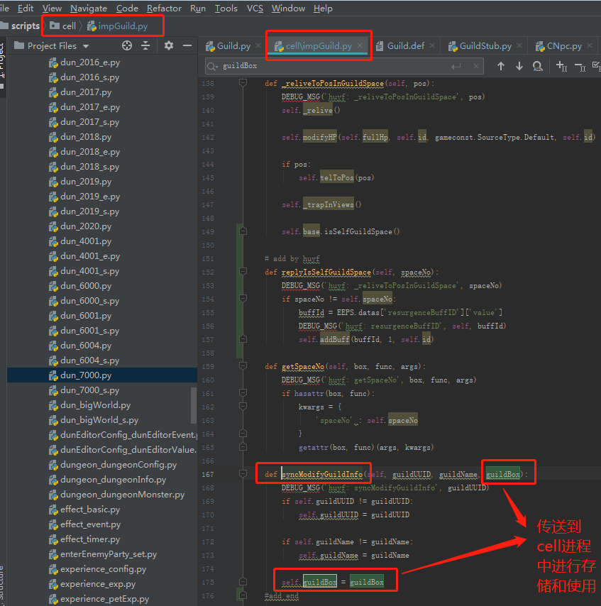

## 6、在同一个进程（cell或者base）中avatar类或者基类中定义的方法，可以在（cell或者base）同一个进程中进行调用不用声明在def文件

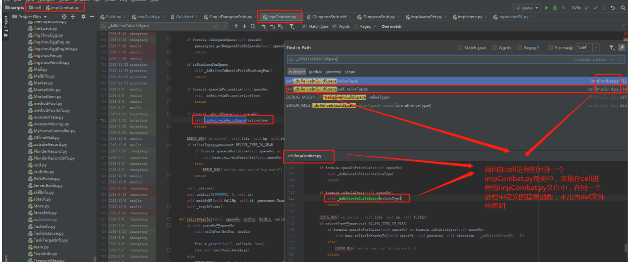

## 7、guild.def文件中的方法调用（在cell或者base进程）因为guild.py在base进程中定义的，所以所有的方法都是BaseMethod项中的

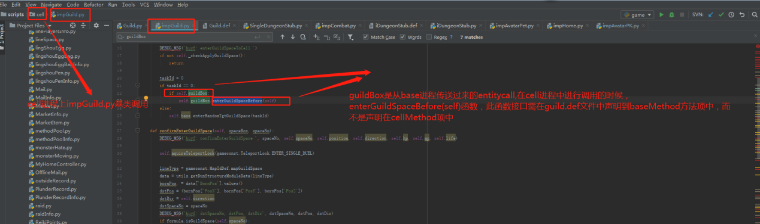

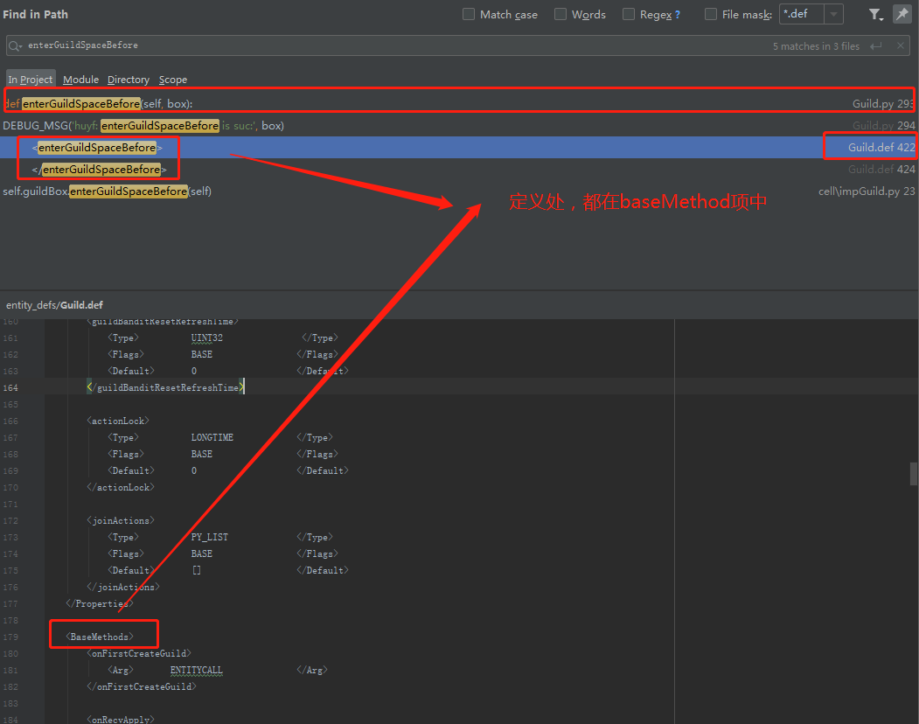

## 8、在avatar基类中声明的Exposed方法

在CellMethod中声明的Exposed方法，程序（在cell进程：av.xxx(id,param)或者base进程中：av.cell.xxx(id,param)）调用时需要设置id参数作为exposed。而guiconsole中不需要设置。（在cell进程：av.xxx(param)或者base进程中：av.cell.xxx(param)）

在BaseMethod中声明的Exposed方法

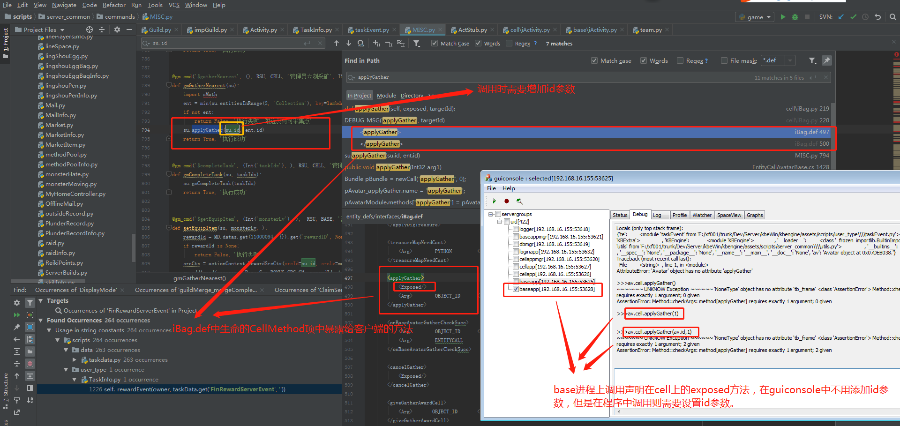

## 9、gameengine.getGlobalBase方法的使用：可以在任何进程调用

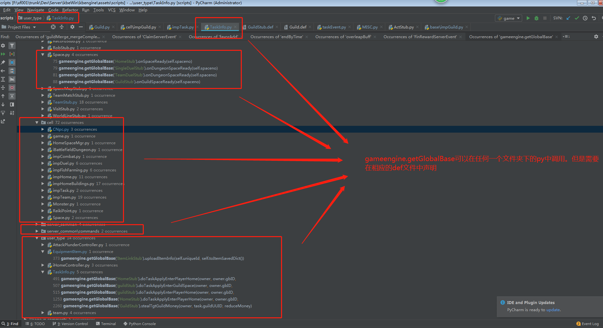

## 10、XXXStub.py只会出现在base进程中，所有只会对外定义BaseMethod方法

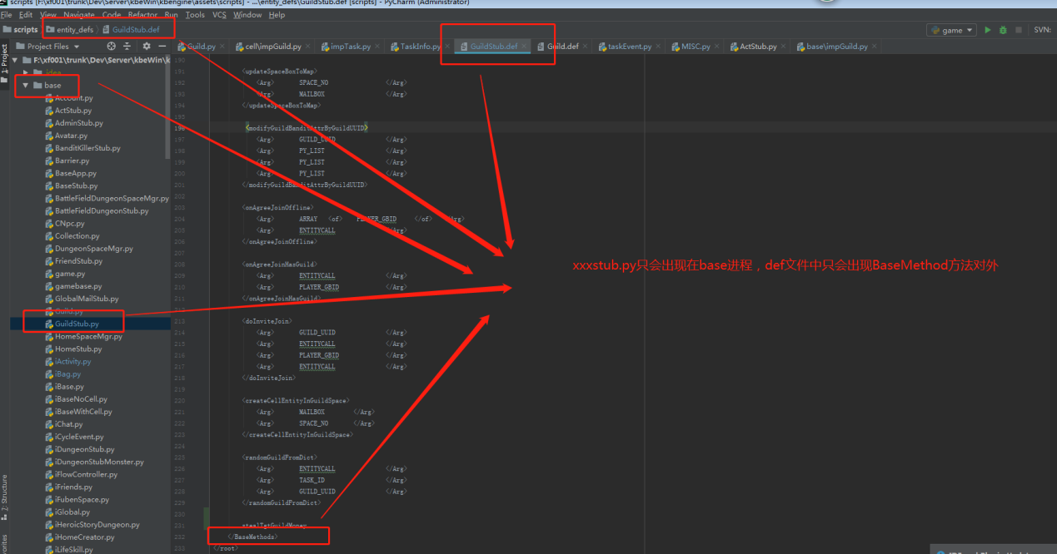

## 11、Databaselength

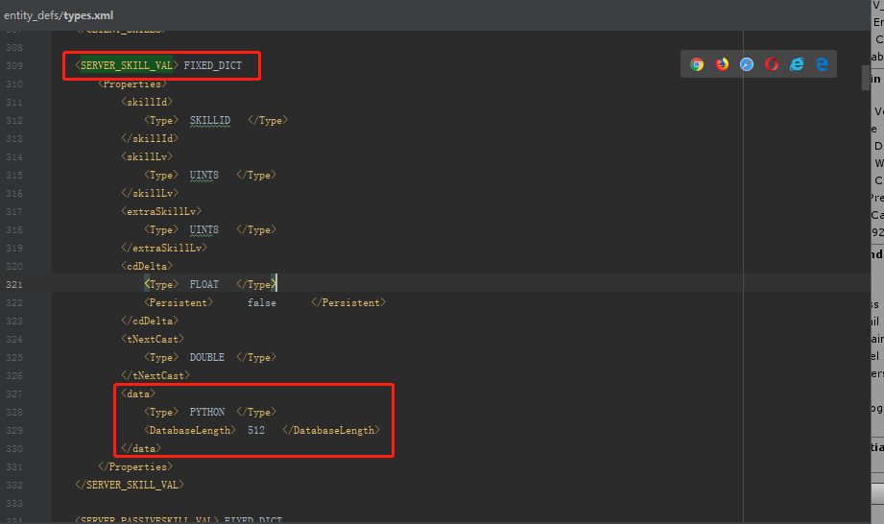

## 12、Properties中属性不需要存储：persistent=false

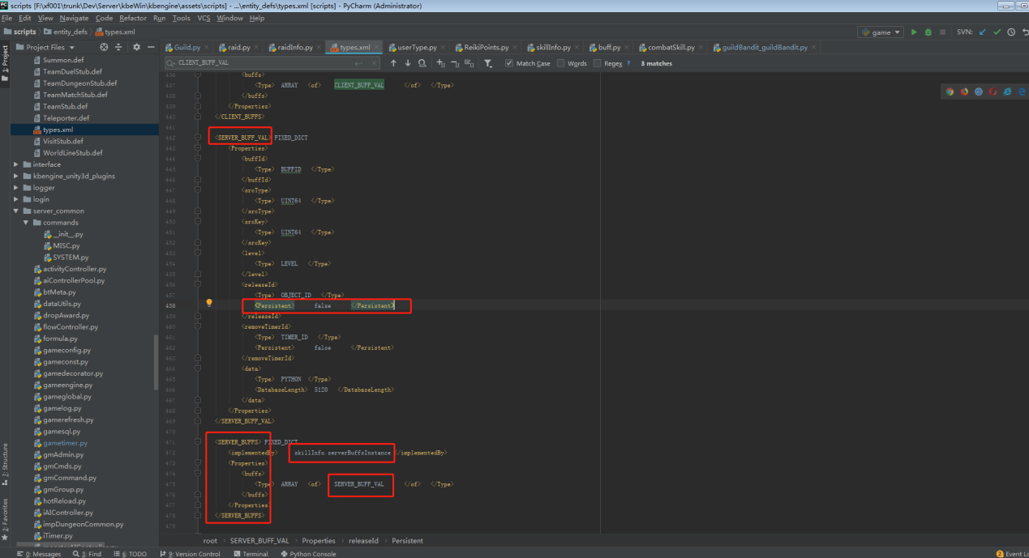

## 13、properties定义为类对象的使用方法

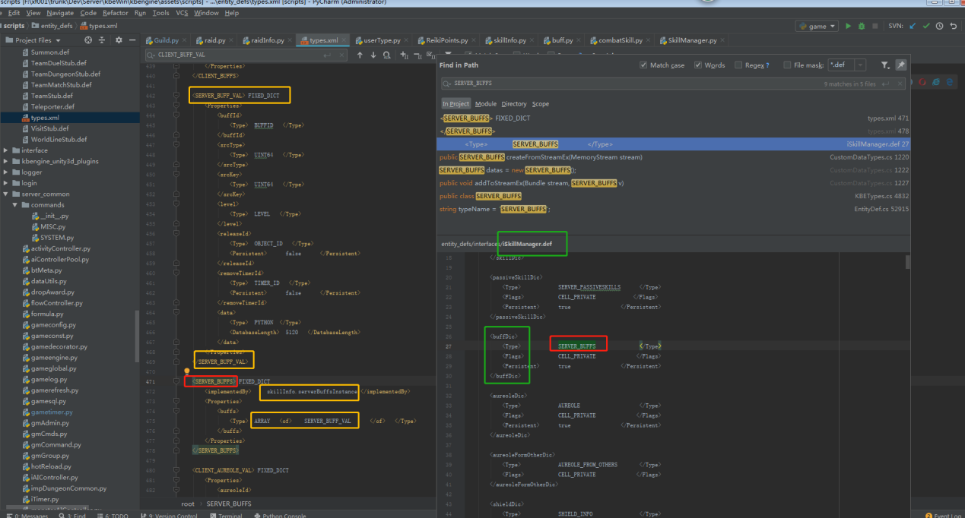

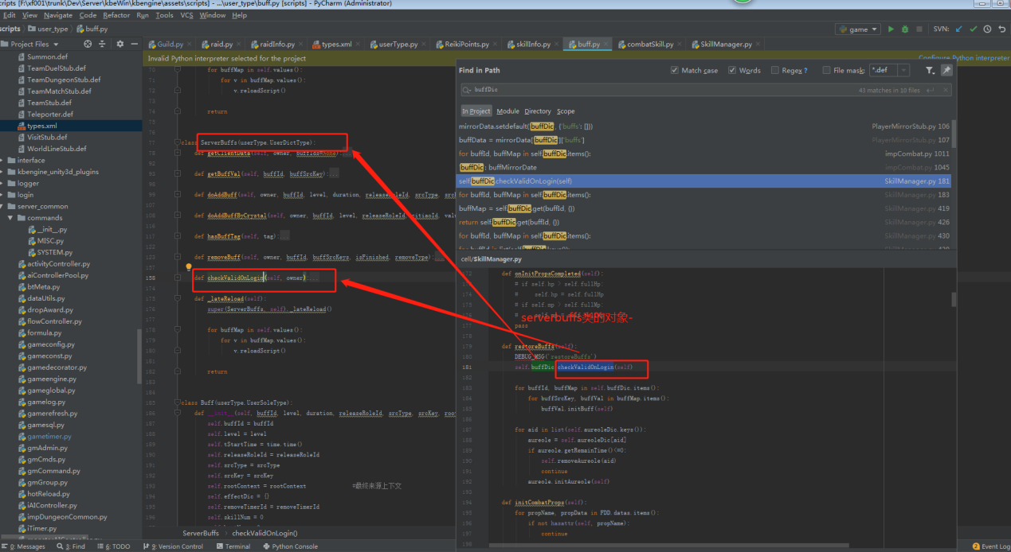

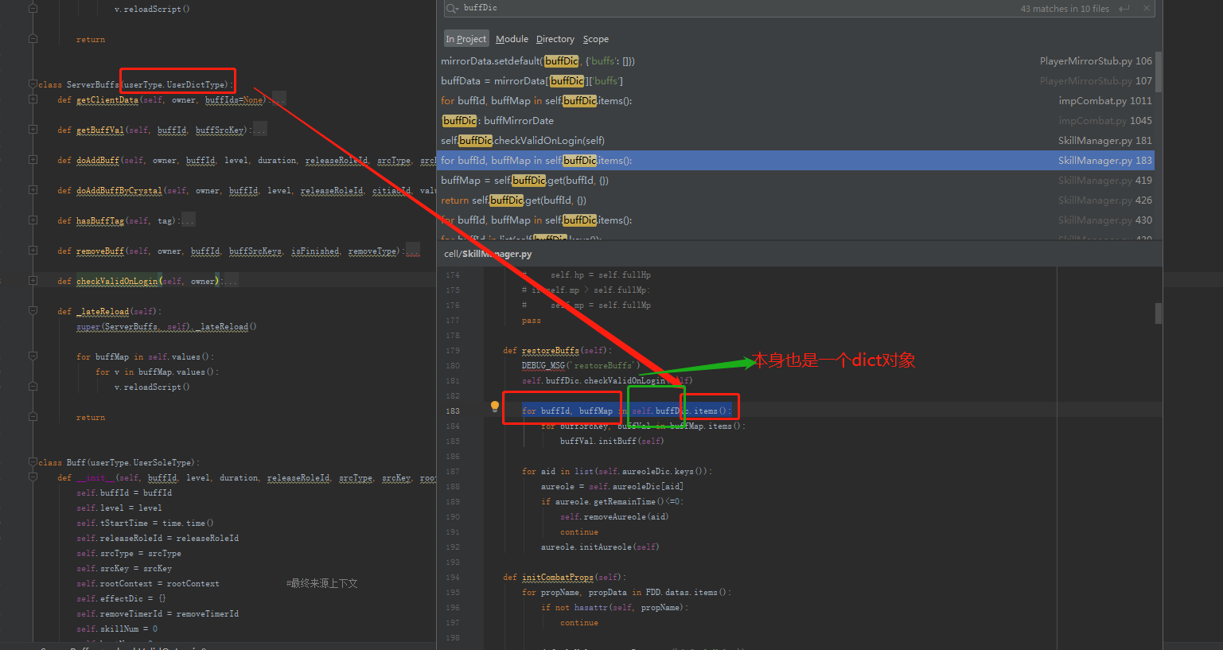

## 14、定义在base/avatar类中的函数在属于base,也可以直接调用avatar的base中的接口

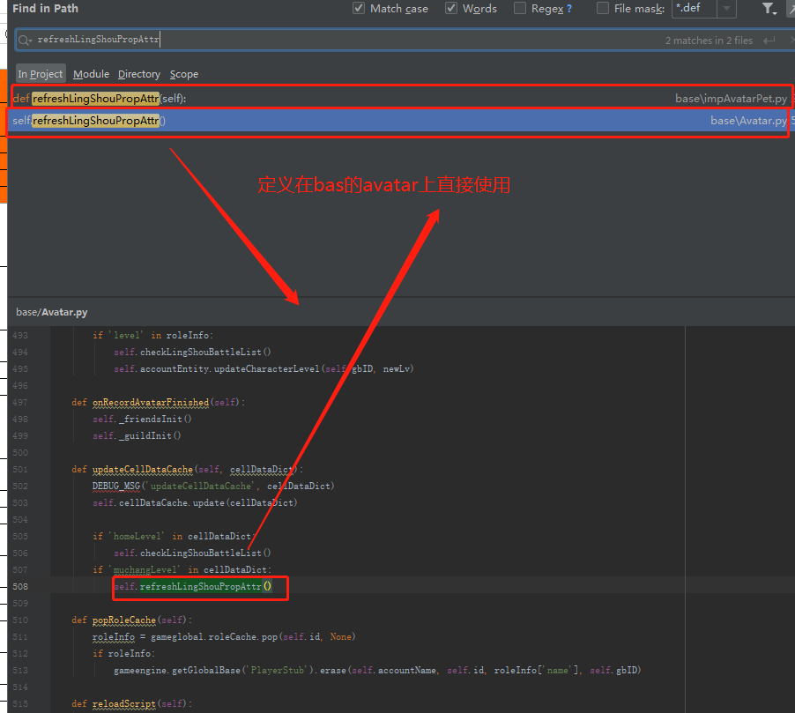

15、定义在cell进程的impXXX中的方法，在cell进程中通过KBEngine.entities.get(self.hostId)获取到en后即可以调用cell上的方法，不用在def声明

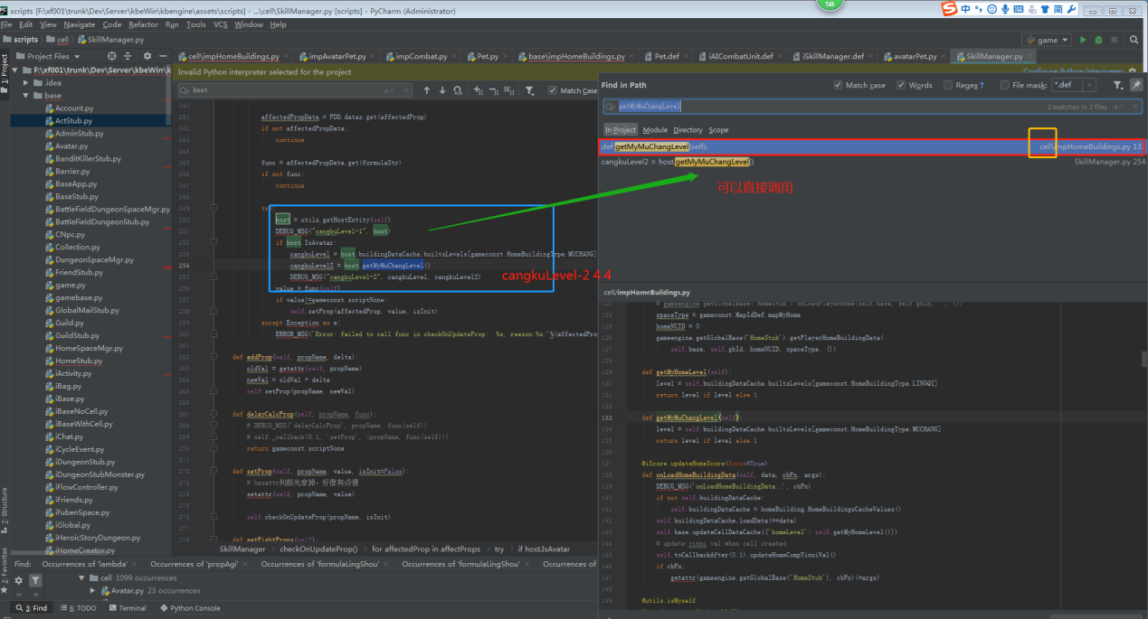

## 15、属性为PYTHON的时候，默认值为None 而非{}，可以使用PY_DICT

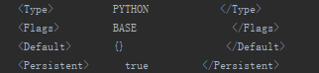

## 16、合适执行getDictFromObj，当参数为自定义对象的时候，调用的时候需要执行序列化

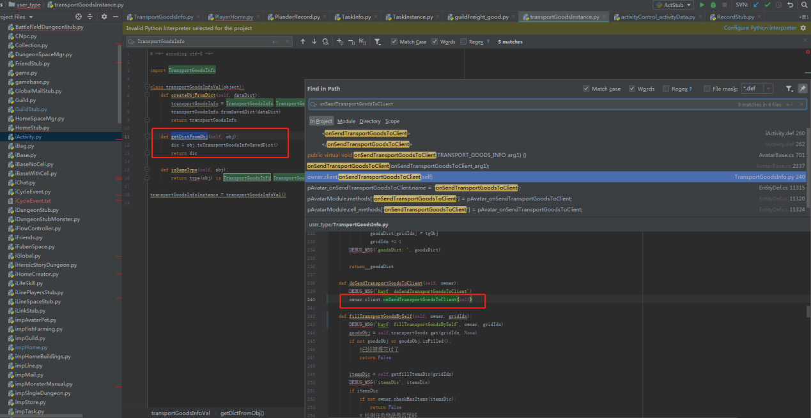

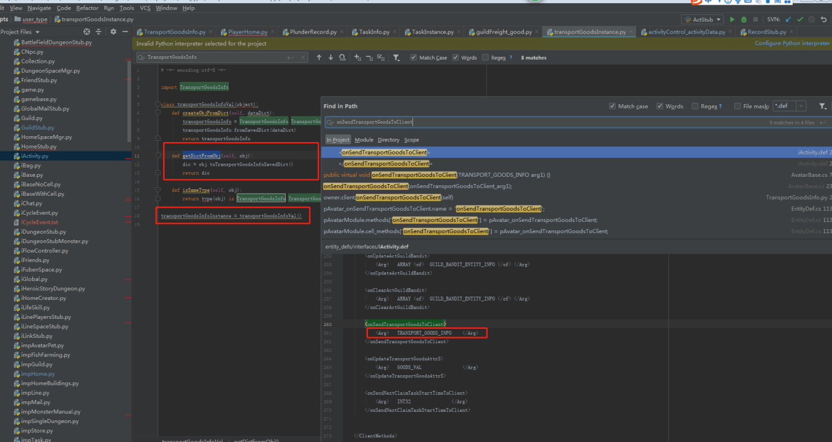

## 17、玩家登陆如果出现自定义数据不匹配

S_DBG baseapp02 422 4227002 [2019-05-15 09:12:44 087] - [Account(6088)]: Account[6088].selectAvatarGame:2814760237834174465. self.avatar=None

S_DBG baseapp02 422 4227002 [2019-05-15 09:12:44 144] - in _dealHistoryTasks

S_DBG baseapp02 422 4227002 [2019-05-15 09:12:44 144] - huyf: TransportGoodsInfo:__init__

S_DBG baseapp02 422 4227002 [2019-05-15 09:12:44 144] - huyf: fromSavedDict

S_ERR baseapp02 422 4227002 [2019-05-15 09:12:44 144] - ~~~~~~~ SCRIPT Exception ~~~~~~

S_ERR baseapp02 422 4227002 [2019-05-15 09:12:44 145] - Locals (only top stack frame):

{'self': "{'helpNum': 0, 'tNextClaimTaskStartTime': 0, 'transportGoods': {}, 'tTaskStartTime': 0, 'tTaskExpireTime': 0, 'transportGoodsNext': {}, 'finalFillState': 0, 'tLastDayUpdateTime': 0}", 'dataDic': "{'helpNum': 0, 'goodsList': [{'gridIdx': 0, 'seekHelpFlag': 0, 'tSeekHelpStart': 0, 'itemNum': 1, 'itemId': 30050003, 'fillFlag': 0}], 'tNextClaimTaskStartTime': 0, 'tTaskStartTime': 1557881244, 'tTas...(more)", 'item': "{'gridIdx': 0, 'seekHelpFlag': 0, 'tSeekHelpStart': 0, 'itemNum': 1, 'itemId': 30050003, 'fillFlag': 0}"}

S_ERR baseapp02 422 4227002 [2019-05-15 09:12:44 145] - Traceback (most recent call last):

File "F:/xf001/trunk/Dev/Server/kbeWin/kbengine/assets/scripts/user_type\transportGoodsInstance.py", line 8, in createObjFromDict

transportGoodsInfo.fromSavedDict(dataDict)

S_ERR baseapp02 422 4227002 [2019-05-15 09:12:44 146] - File "F:/xf001/trunk/Dev/Server/kbeWin/kbengine/assets/scripts/user_type\TransportGoodsInfo.py", line 105, in fromSavedDict

goodObj = TransportGoods(item['gridIdx'], item['itemId'], item['num'])

S_ERR baseapp02 422 4227002 [2019-05-15 09:12:44 147] - KeyError: 'num'

ERROR baseapp02 422 4227002 [2019-05-15 09:12:44 147] - FixedDictType::impl_createObjFromDict: transportGoodsInstance.transportGoodsInfoInstance.isSameType() is failed!

S_ERR baseapp02 422 4227002 [2019-05-15 09:12:44 148] - ~~~~~~~ UNKNOW Exception ~~~~~~ 'NoneType' object has no attribute 'tb_frame' <class 'TypeError'> data must be set to TRANSPORT_GOODS_INFO

S_ERR baseapp02 422 4227002 [2019-05-15 09:12:44 148] - TypeError: data must be set to TRANSPORT_GOODS_INFO

ERROR baseapp02 422 4227002 [2019-05-15 09:12:44 148] - Baseapp::createDictDataFromPersistentStream: Avatar.transportGoodsInfo error, set to default!

S_DBG baseapp02 422 4227002 [2019-05-15 09:12:44 149] - huyf: TransportGoodsInfo:__init__

S_DBG baseapp02 422 4227002 [2019-05-15 09:12:44 149] - huyf: fromSavedDict

S_DBG baseapp02 422 4227002 [2019-05-15 09:12:44 149] - huyf: fromSavedDict {} {} 0 0 0 0 0 0

S_DBG baseapp02 422 4227002 [2019-05-15 09:12:44 157] - in _dealHistoryTasks

S_DBG baseapp02 422 4227002 [2019-05-15 09:12:44 157] - huyf: TransportGoodsInfo:__init__

S_DBG baseapp02 422 4227002 [2019-05-15 09:12:44 157] - huyf: fromSavedDict

S_DBG baseapp02 422 4227002 [2019-05-15 09:12:44 158] - huyf: fromSavedDict {} {} 0 0 0 0 0 0

INFO baseapp02 422 4227002 [2019-05-15 09:12:44 158] - EntityApp::createEntity: new Avatar 6131

## 18、如果只是在本进程（cell或者base等）中调用则不用在def中进行声明，直接使用即可

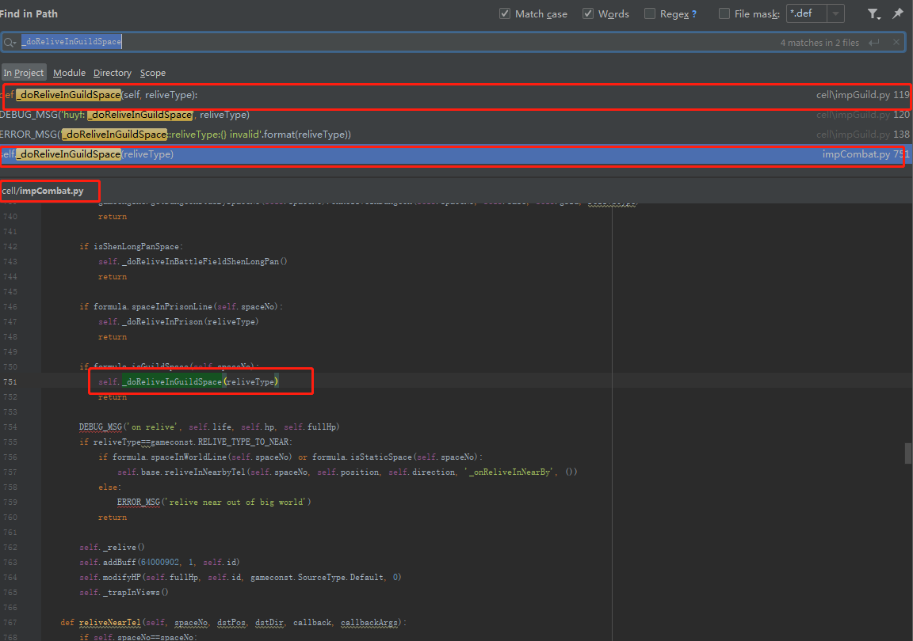

## 19、玩家登陆

DEBUG baseapp01 422 4227002 [2019-06-01 06:13:39 206] - PendingLoginMgr::add: 1:abca29, size=1.

DEBUG baseapp01 422 4227002 [2019-06-01 06:13:39 225] - Channel::handshake: kcp(192.168.16.155:49593/3/0/0) successfully!

INFO baseapp01 422 4227002 [2019-06-01 06:13:39 252] - ServerApp::onHello: verInfo=2.3.5, scriptVerInfo=0.1.0, encryptedKey=None, addr:192.168.16.155:49593/3/0/0

WARNING baseapp01 422 4227002 [2019-06-01 06:13:39 252] - Baseapp::onHello: client is not encrypted, addr=192.168.16.155:49593/3/0/0

INFO baseapp01 422 4227002 [2019-06-01 06:13:39 283] - Baseapp::loginBaseapp: new user[1:abca29], channel[192.168.16.155:49593/3/0/0].

INFO baseapp01 422 4227002 [2019-06-01 06:13:39 283] - Baseapp::loginBaseapp: user[1:abca29] has entity(498).

S_INFO baseapp01 422 4227002 [2019-06-01 06:13:39 284] - [Account(498)]: onLogOnAttempt 192.168.16.155 49593 <Swallower object at 0x001C0028> Avatar object at 0x07F8E368. True

S_INFO baseapp01 422 4227002 [2019-06-01 06:13:39 284] - [Account(498)]: Account[498]::onClientEnabled:entities enable. entityCall:Client id:498, utype:38, component=client[0], addr: 192.168.16.155:49593., clientType(7), clientDatas=((b'{"token":"MRAjWwhTHctcuAx", "loginServerId":1}', b'{"token":"MRAjWwhTHctcuAx", "loginServerId":1}')), hasAvatar=500, accountName=abca29 Avatar object at 0x07F8E368. True

S_INFO baseapp01 422 4227002 [2019-06-01 06:13:39 422] - [Account(498)]: reloginAvatar True 500

S_INFO baseapp01 422 4227002 [2019-06-01 06:13:39 423] - [Avatar(500)]: Avatar[500-2814759035545321473] entities enable. entityCall:Client id:500, utype:39, component=client[0], addr: 192.168.16.155:49593. True 0

S_DBG baseapp01 422 4227002 [2019-06-01 06:13:39 423] - [Avatar(500)]: _initNewbie

S_INFO baseapp01 422 4227002 [2019-06-01 06:13:39 425] - [Avatar(500)]: onCellGetWitness 1 2814759035545321473

S_DBG baseapp01 422 4227002 [2019-06-01 06:13:39 425] - [Avatar(500)]: in sendBagData

S_DBG baseapp01 422 4227002 [2019-06-01 06:13:39 426] - [Avatar(500)]: sendJuLingDingInfoToClient:: {'julingding': [], 'yinni': 100.0}

S_DBG baseapp01 422 4227002 [2019-06-01 06:13:39 426] - [Avatar(500)]: initLingShou True

S_DBG baseapp01 422 4227002 [2019-06-01 06:13:39 426] - [ActStub(10)]: in getOpendActList: {32000009, 32000004}

S_DBG baseapp01 422 4227002 [2019-06-01 06:13:39 426] - [Avatar(500)]: in reqGetMarketItemsList

S_DBG baseapp01 422 4227002 [2019-06-01 06:13:39 427] - [Avatar(500)]: huyf: updateTransportGoodsTask 32000009

S_DBG baseapp01 422 4227002 [2019-06-01 06:13:39 427] - [Avatar(500)]: huyf: getTaskExpireTime 0

S_DBG baseapp01 422 4227002 [2019-06-01 06:13:39 427] - [Avatar(500)]: huyf: updateTransportGoodsTask 0 32000009 Avatar object at 0x07F8E368.

S_DBG baseapp01 422 4227002 [2019-06-01 06:13:39 427] - [Avatar(500)]: huyf: getTaskExpireTime 0

S_DBG baseapp01 422 4227002 [2019-06-01 06:13:39 427] - [Avatar(500)]: ckz: _sendFriendList

S_DBG baseapp01 422 4227002 [2019-06-01 06:13:39 427] - [Avatar(500)]: ckz: _sendRequestList

S_DBG baseapp01 422 4227002 [2019-06-01 06:13:39 428] - [Avatar(500)]: onAvatarGuildRelogin 0

S_DBG baseapp01 422 4227002 [2019-06-01 06:13:39 432] - [Avatar(500)]: updateCellDataCache {'homeLevel': 1}

S_INFO baseapp01 422 4227002 [2019-06-01 06:13:39 432] - [Avatar(500)]: unLockBattleList 3

S_WARN baseapp02 422 4227001 [2019-06-01 06:13:39 428] - [PlayerHome(6569)]: DEBUG:: send home building data to client: {"buildings": {"1": {"nm": "lingqi", "lvl": 0, "tp": 1}, "2": {"nm": "shuijing", "lvl": 0, "tp": 2}, "3": {"o": {"muid": 0, "pt": 0}, "nm": "", "s": {"muid": 0, "pt": 0}, "lvl": 0, "tp": 3}, "4": {"hsn": 0, "30000006": 0, "30000007": 0, "nm": "cangku", "lsn": 0, "lvl": 0, "tp": 4}, "5": {"d_cml_n": 0, "advs": {}, "nm": "jiuguan", "nxt_task_ct": 0, "lvl": 0, "tasks": {}, "tp": 5}}, "b_lc_c": {}, "name": "\u5c0f\u4e16\u754c"}

S_DBG baseapp02 422 4227001 [2019-06-01 06:13:39 428] - [PlayerHome(6569)]: loadHomeBuildingCacheData:: 2814759035545321473

S_DBG baseapp02 422 4227001 [2019-06-01 06:13:39 428] - [SingleDungeonStub(6073)]: sendBigWorldDungeonProps::

S_DBG baseapp01 422 4227002 [2019-06-01 06:13:39 525] - [Avatar(500)]: updateHomeCompYinniVal:: 0 1559340819

S_DBG baseapp01 422 4227002 [2019-06-01 06:13:39 525] - [Avatar(500)]: updateYinni:: 100.0 -> 99.93 1559340819

S_DBG baseapp01 422 4227002 [2019-06-01 06:13:39 525] - [Avatar(500)]: updateJuLingDingYinniToClient::

S_DBG baseapp01 422 4227002 [2019-06-01 06:13:39 622] - [Avatar(500)]: in sendTaskList

S_DBG baseapp01 422 4227002 [2019-06-01 06:13:39 722] - [Avatar(500)]: in getOfflineMailsByGBID, sql: SELECT sm_toGBID, sm_mailId, sm_createTime, sm_extraJson FROM tbl_OfflineMail WHERE sm_toGBID=2814759035545321473

S_DBG baseapp01 422 4227002 [2019-06-01 06:13:39 745] - [Avatar(500)]: in _checkOfflineMailsCB: [] None None None True

S_DBG baseapp01 422 4227002 [2019-06-01 06:13:39 745] - [Avatar(500)]: in getMyGlobalsMails, lastGBMailTime: 1559340688

DEBUG baseapp01 422 4227002 [2019-06-01 06:13:40 191] - PendingLoginMgr::process: [1:abca29] is timeout, currsize=0.

S_DBG baseapp01 422 4227002 [2019-06-01 06:13:40 322] - [Avatar(500)]: sendMonsterSoulCards

S_DBG baseapp01 422 4227002 [2019-06-01 06:13:40 522] - [Avatar(500)]: _doSendProssessionMonsters

S_DBG baseapp01 422 4227002 [2019-06-01 06:13:49 237] - [Avatar(500)]: getMyHome

S_DBG baseapp01 422 4227002 [2019-06-01 06:13:49 238] - [Avatar(500)]: zt: onGetMyHomeBase 6697317258282598401

## 20、数据库表和字段相关

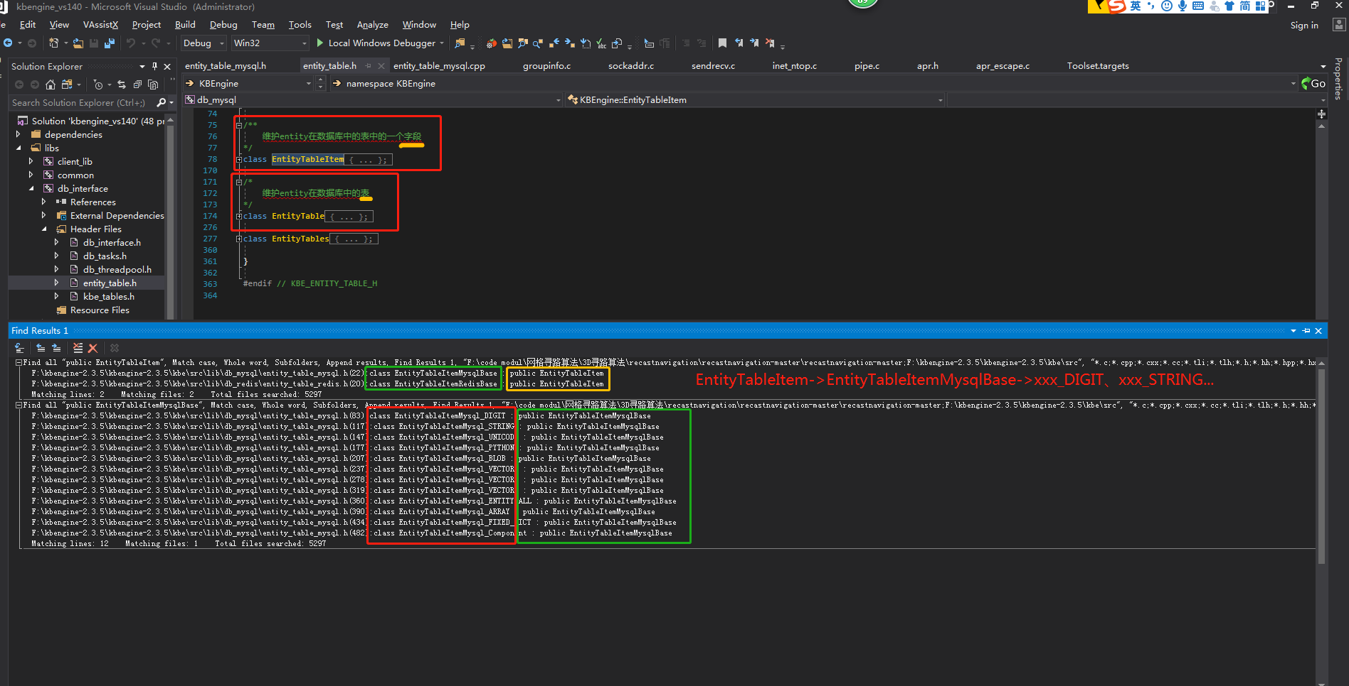



## 21、实体相应的字段和方法（Space）🡪

|  |  |  |  |
| --- | --- | --- | --- |
|  | **Name** | **Value** | **Type** |
| ▶ | entitiesFile | "D:/XingFeiGame/trunk/Dev/Server/kbeWin/kbengine/assets/scripts/entities.xml" | std::basic_string<char,std::char_traits<char>,std::allocator<char> > |

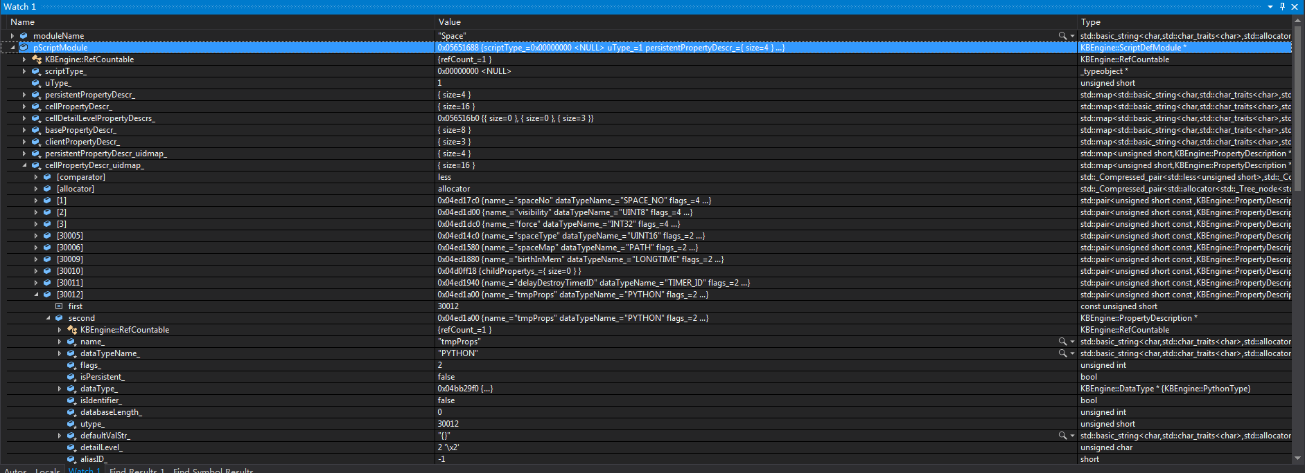

## KBEngine.executeRawDatabaseCommand回调函数的使用

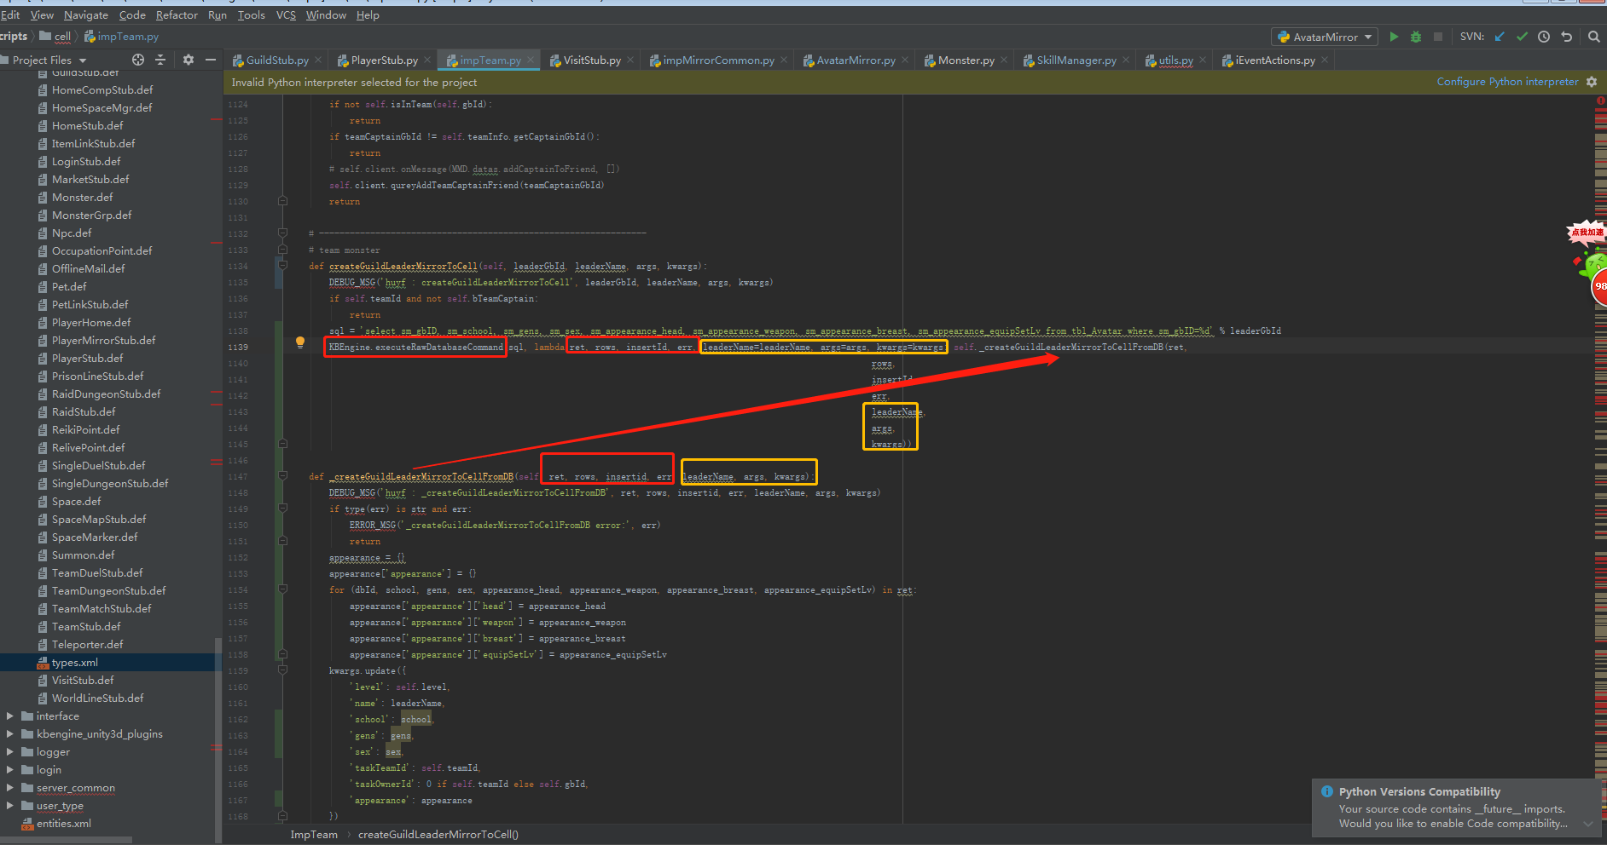

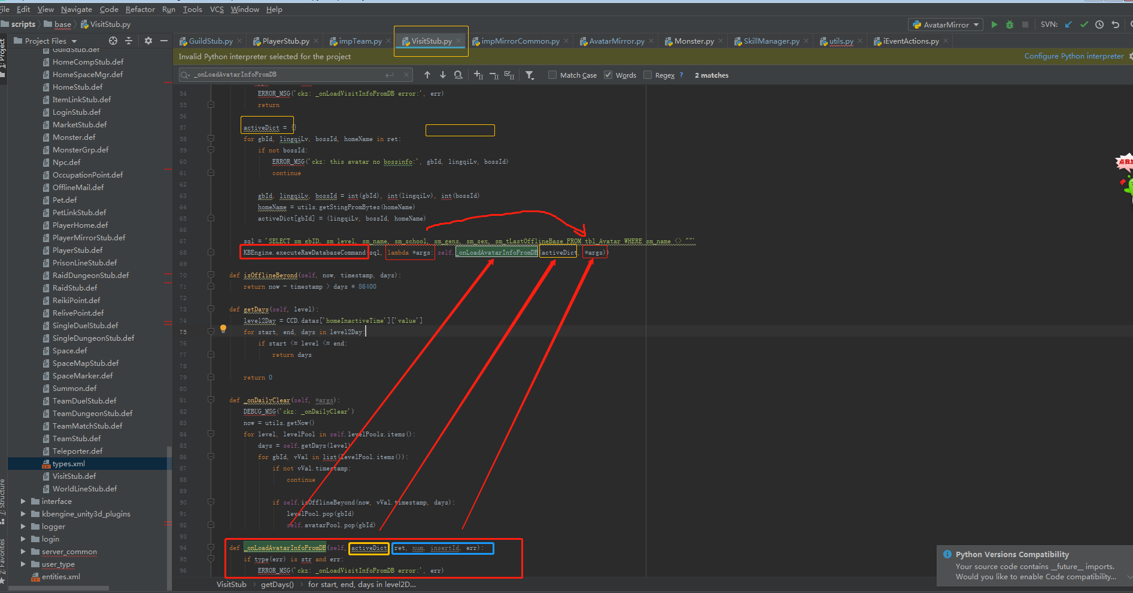

# KBEngine引擎-C++引擎层

## 执行流程

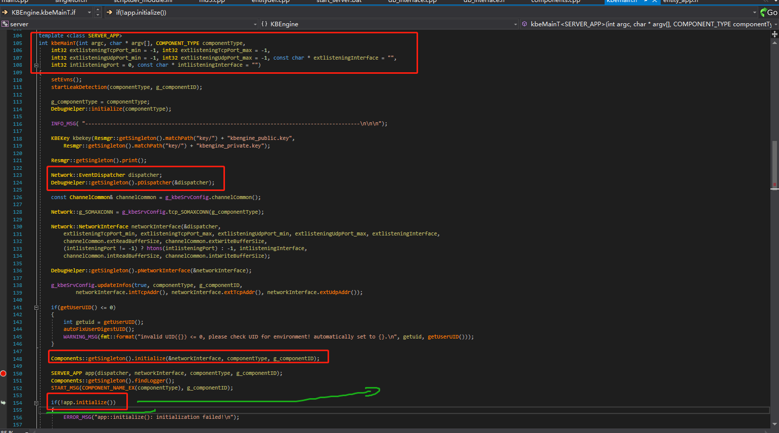

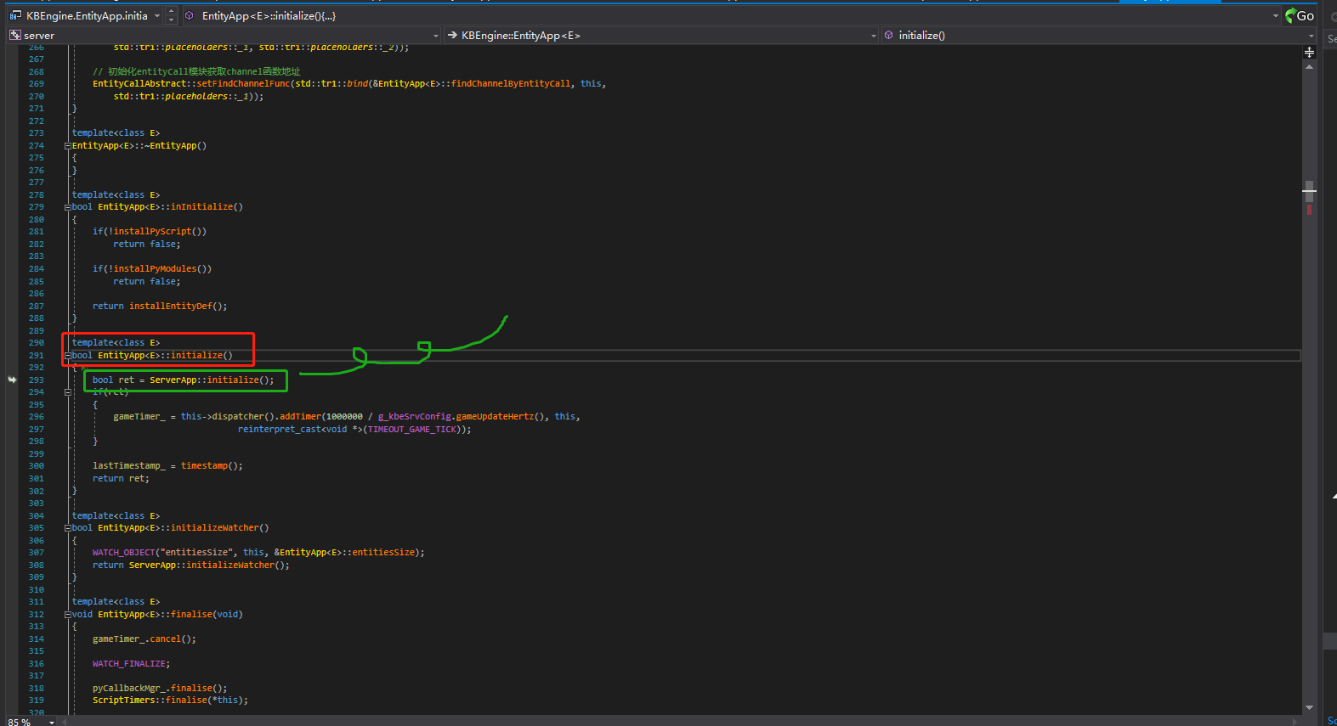

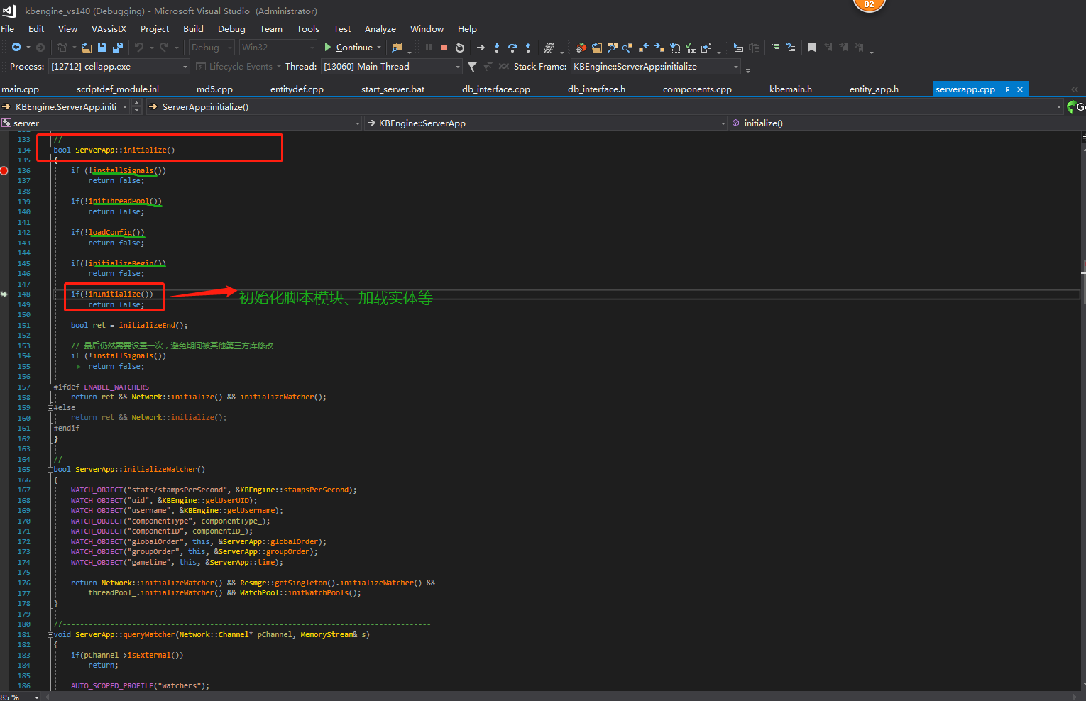

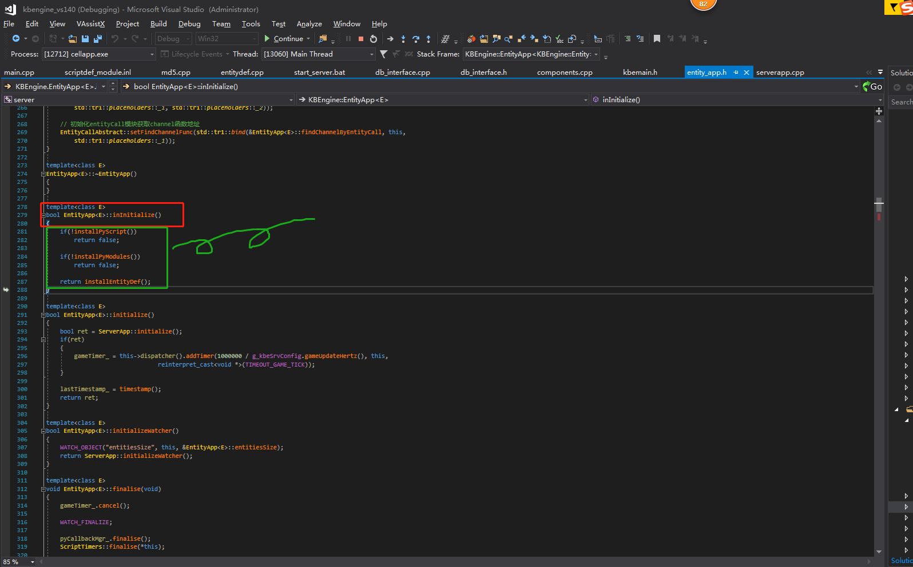

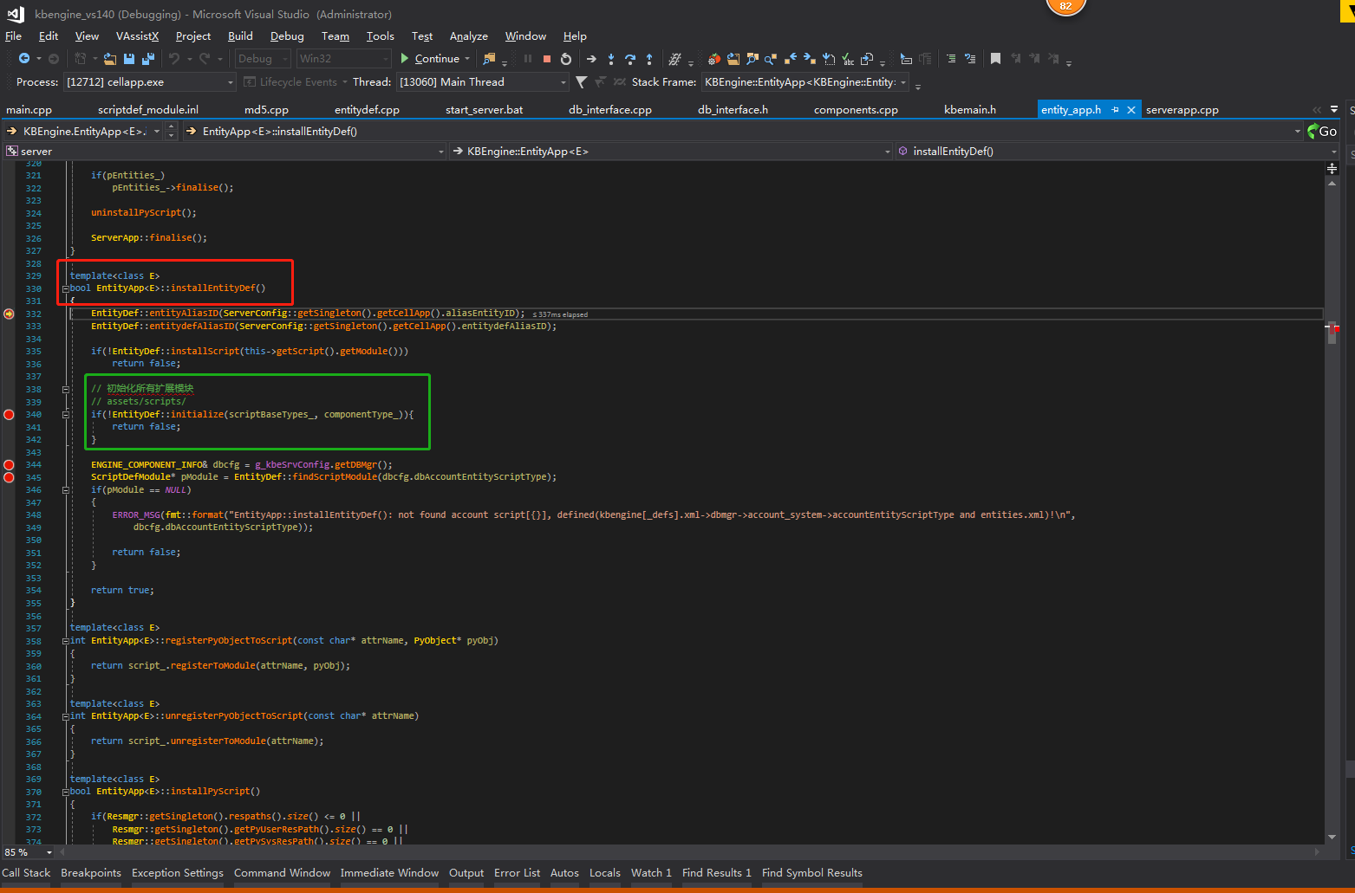

ServerApp::initialize()->EntityApp<E>::inInitialize()->EntityApp<E>::installEntityDef()->EntityDef::initialize->DataTypes::initialize(defFilePath + "types.xml")

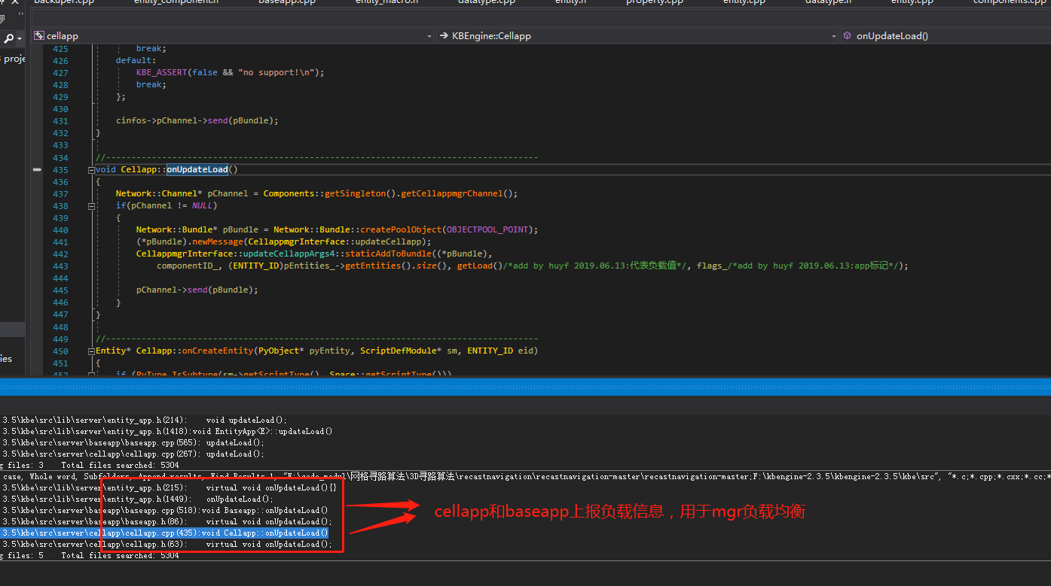

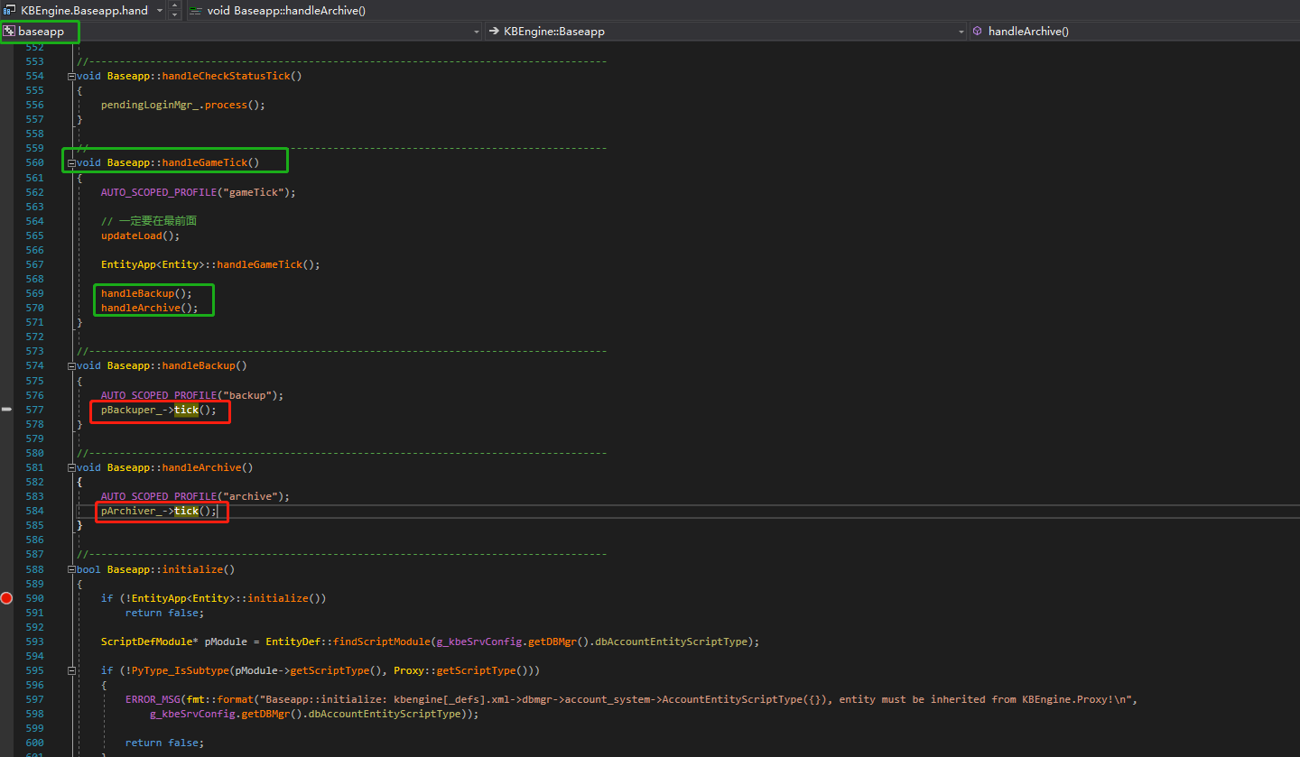

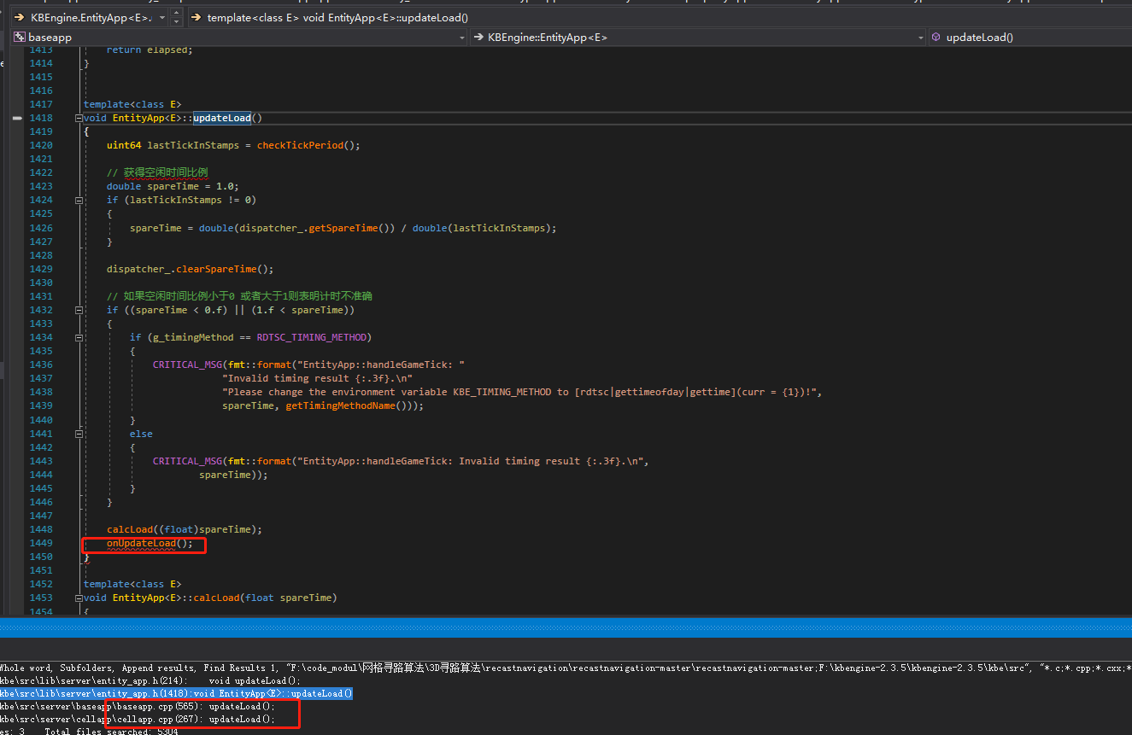

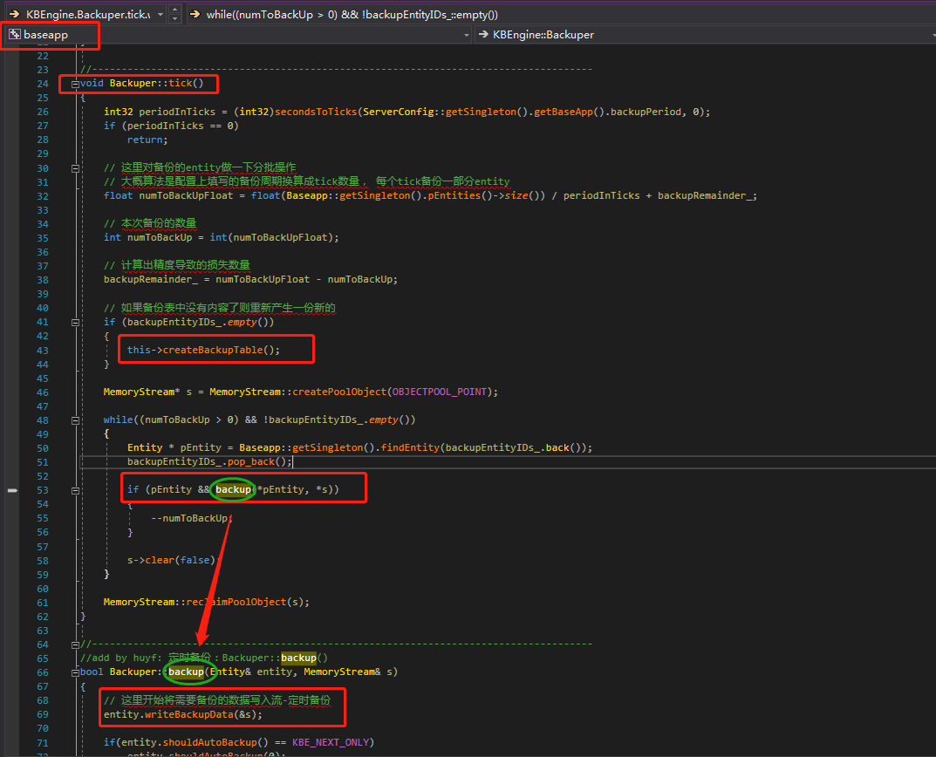

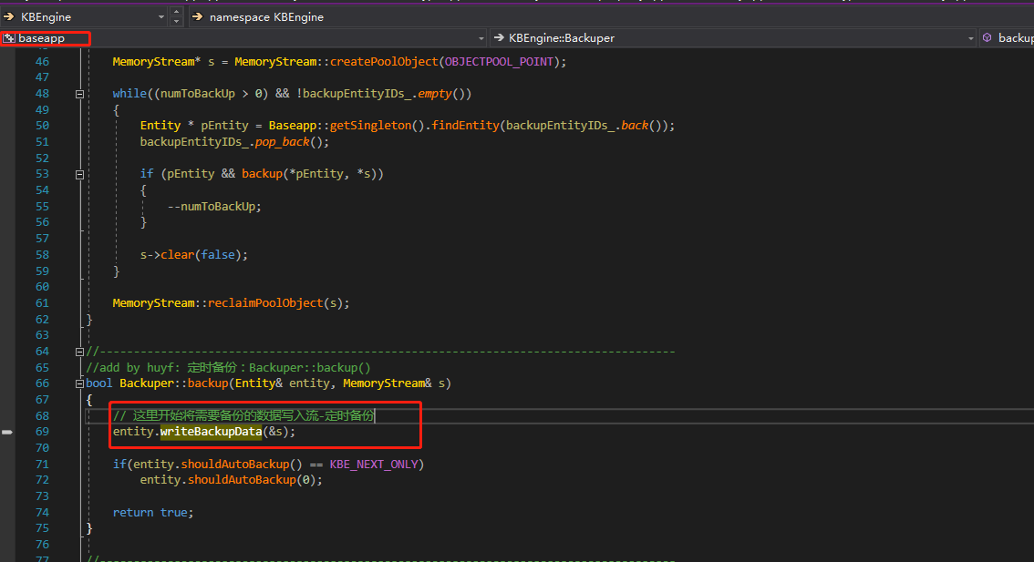

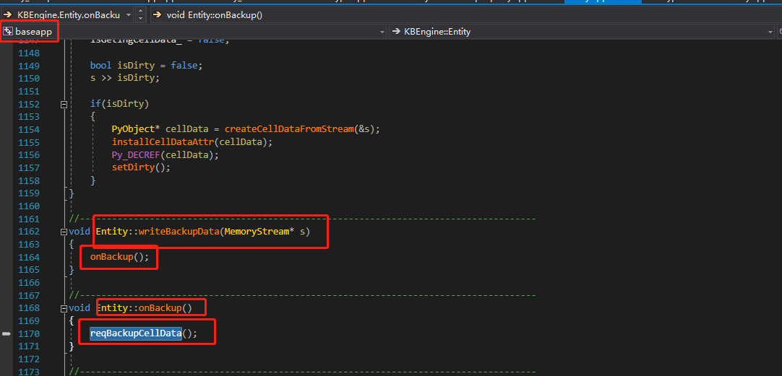

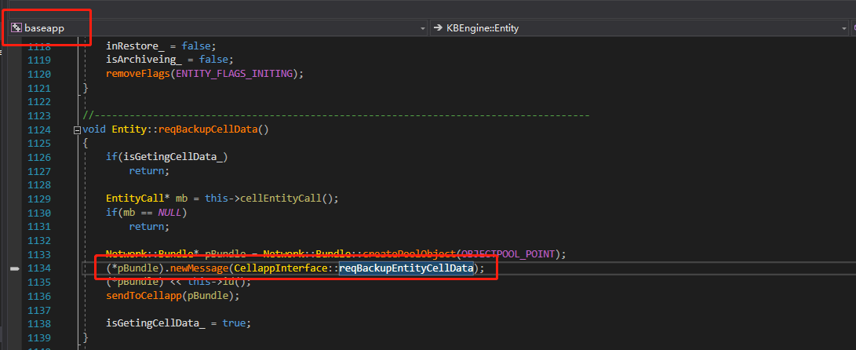

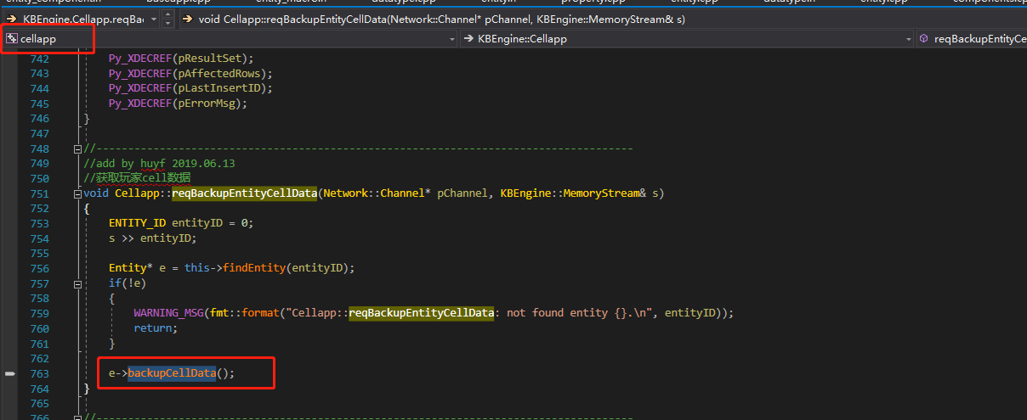

Cellapp::Entity::backupCellData()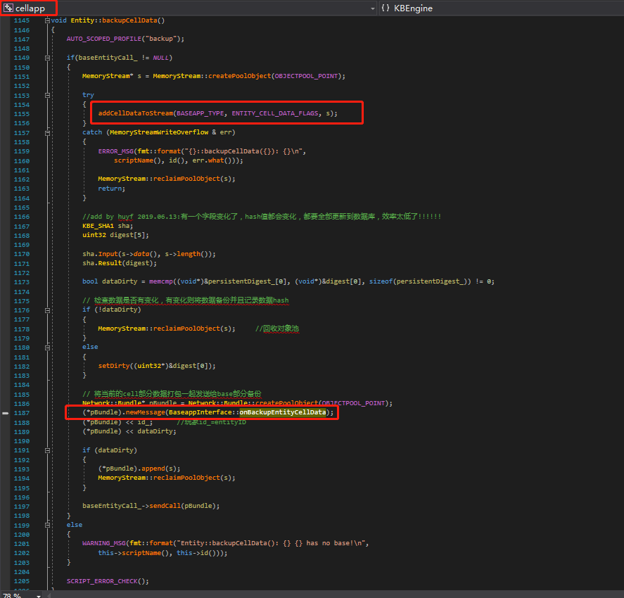🡪Entity::addCellDataToStream()return PyObject* cellData

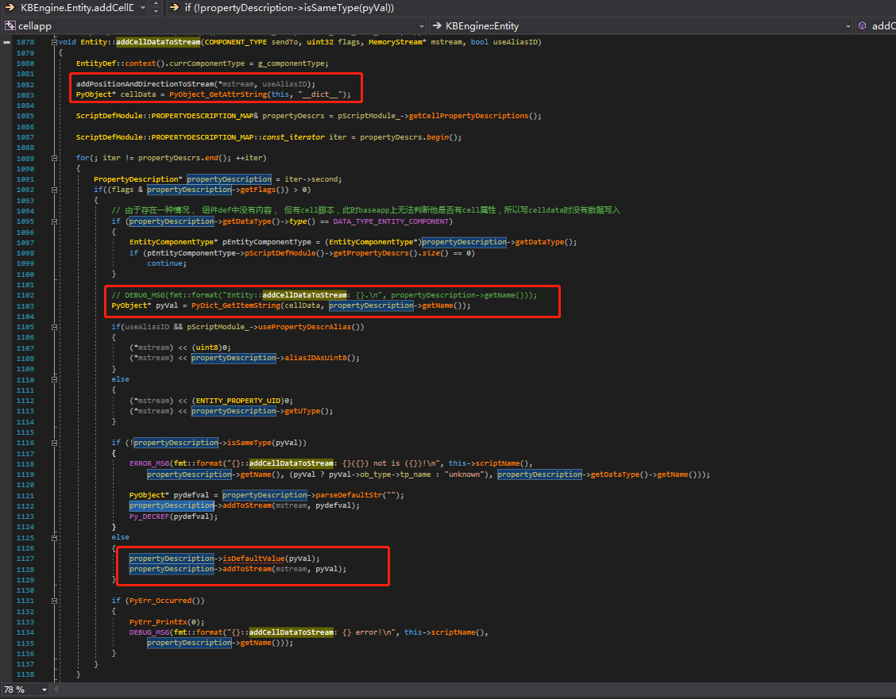🡪Baseapp::onBackupEntityCellData 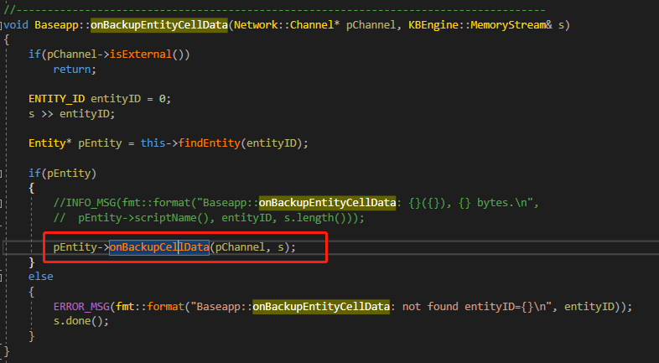🡪 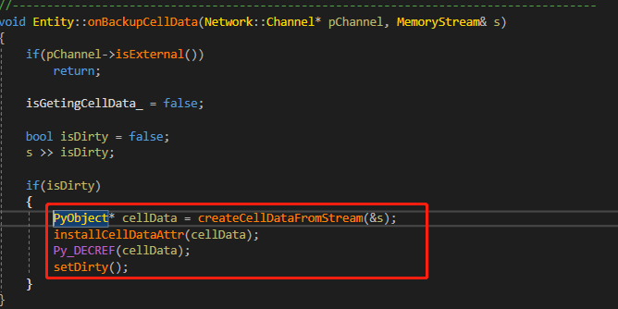

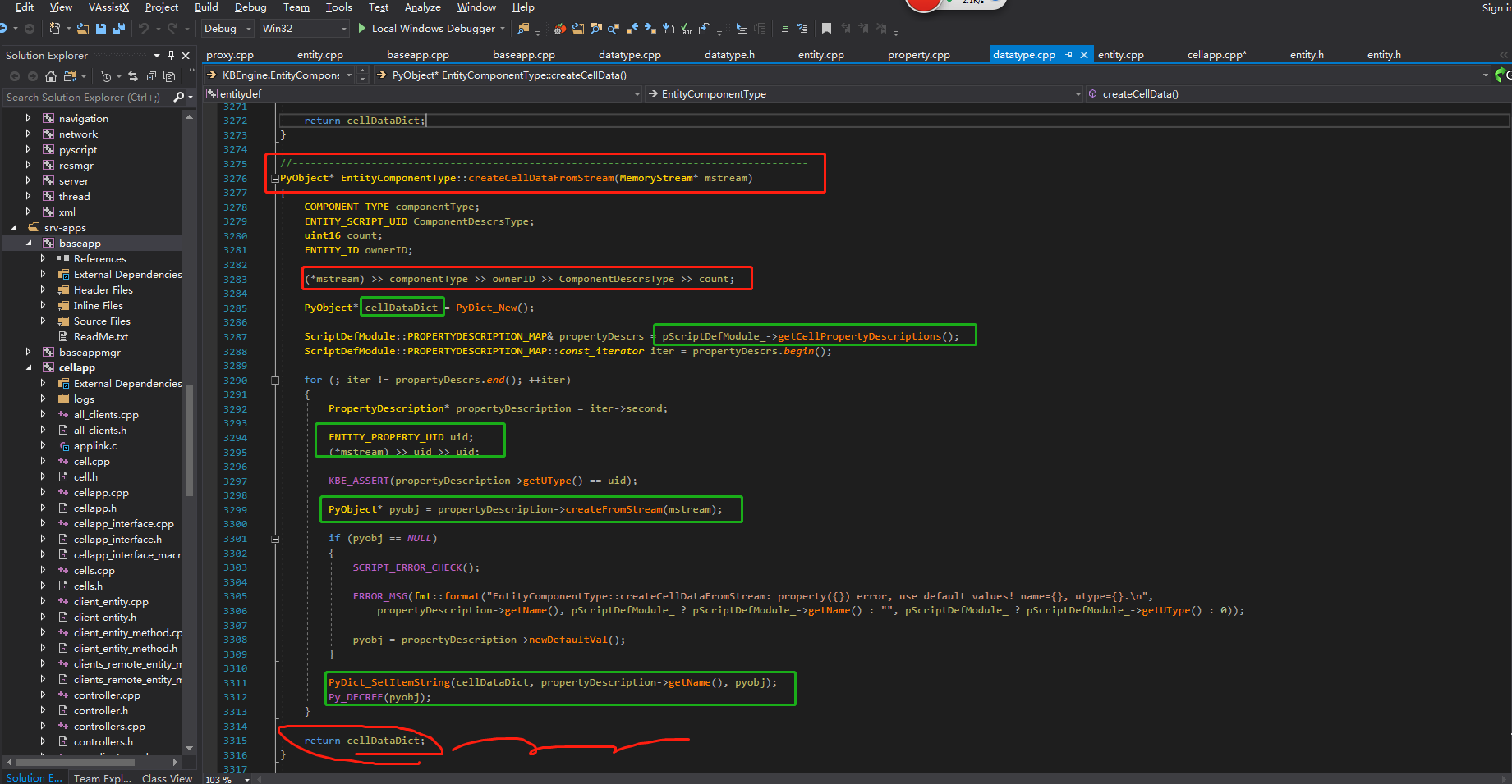

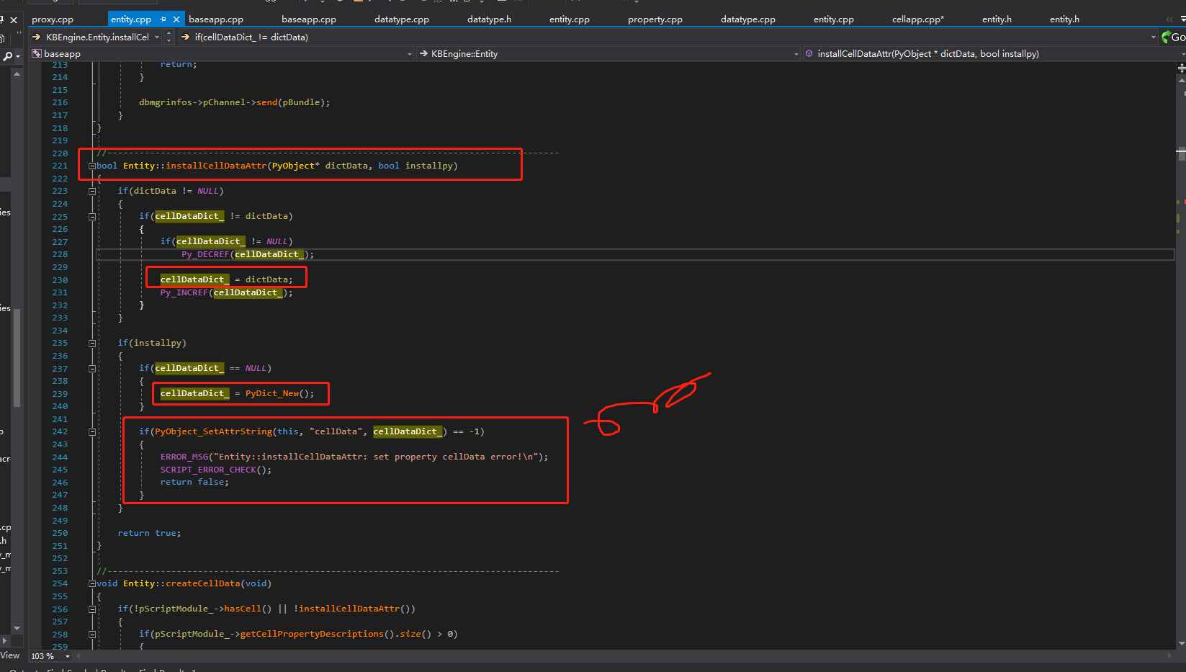

Base进程中的celldata

createCellEntity-base进程暴露的方法

def createCellEntity( self, cellEntityMB ):

功能说明：

请求在一个cell里面创建一个关联的实体。

用于创建cell实体的信息被存储在该实体的属性cellData里。这个属性是一个字典，对应实体的.def文件里的默认值，同时还包括用于表示

实体位置和方向(roll, pitch, yaw)的"position", "direction" 和 "spaceID"。

参数： cellEntityMB 一个可选的CellEntityCall参数，指定哪个空间里创建这个cell实体的。

只能使用一个直接的CellEntityCall。如果你有一个实体的BaseEntityCall，你不可以使用baseEntityCall.cell传给这个函数。

你必须在这个实体的base上创建一个新的函数来回传这个直接的CellEntityCall。

例如：

baseEntityCallOfNearbyEntity.createCellNearSelf( self )

在实体的base上：

def createCellNearSelf( self, baseEntityCall ):

baseEntityCall.createCellNearHere( self.cell )

在原实体的base上调用createCellNearSelf()方法：

def createCellNearHere( self. cellEntityCall ):

self.createCellEntity( cellEntityCall )

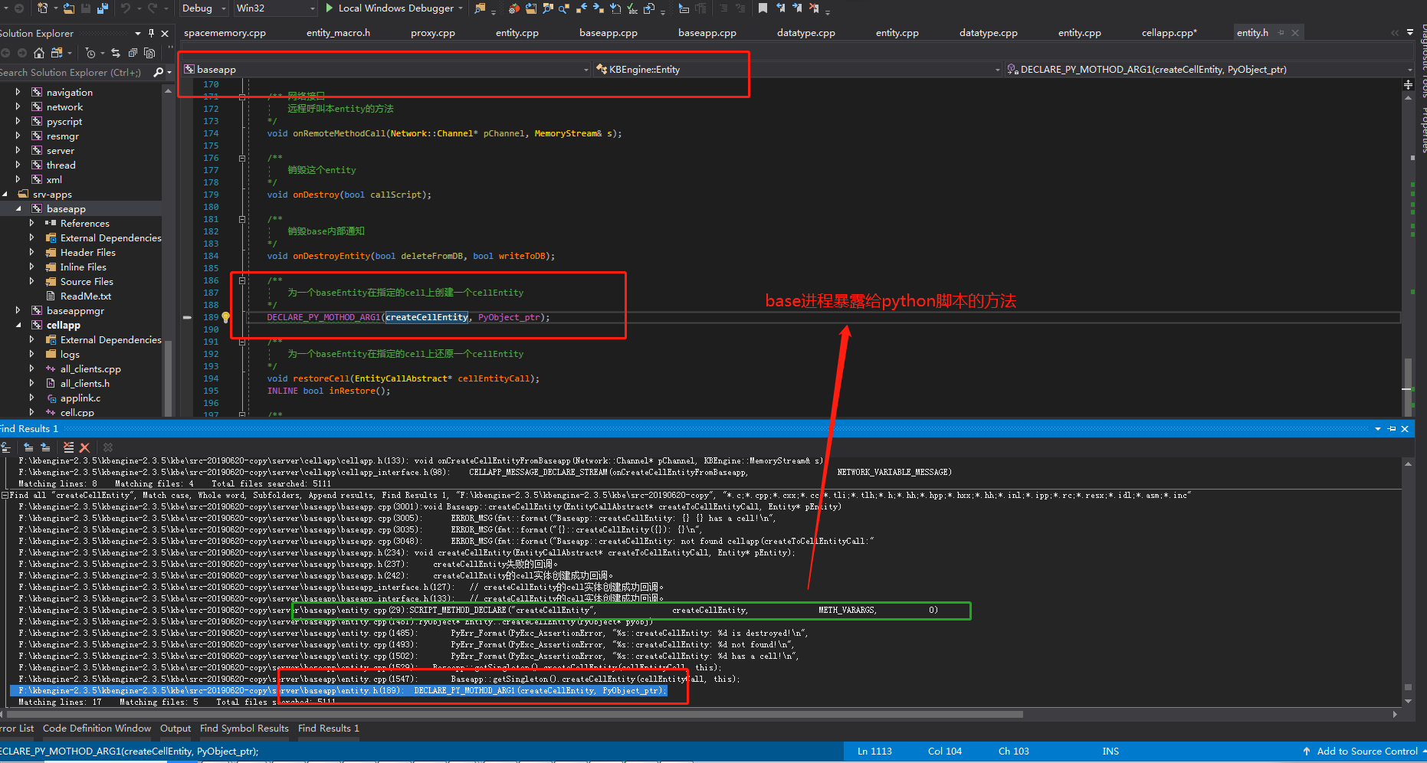

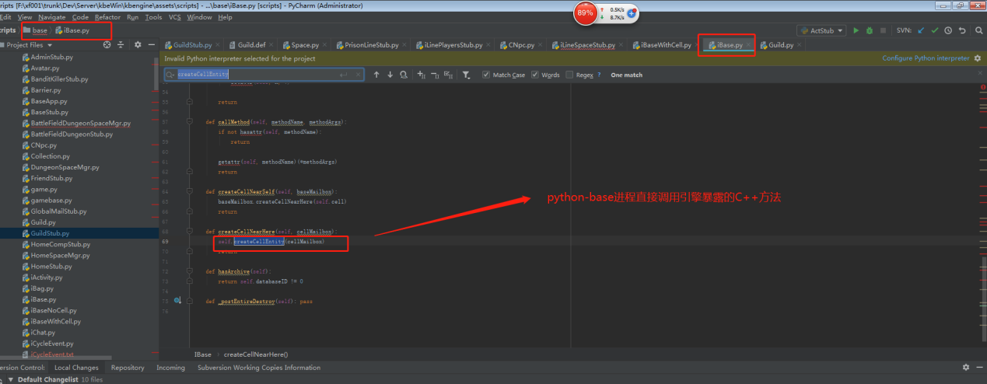

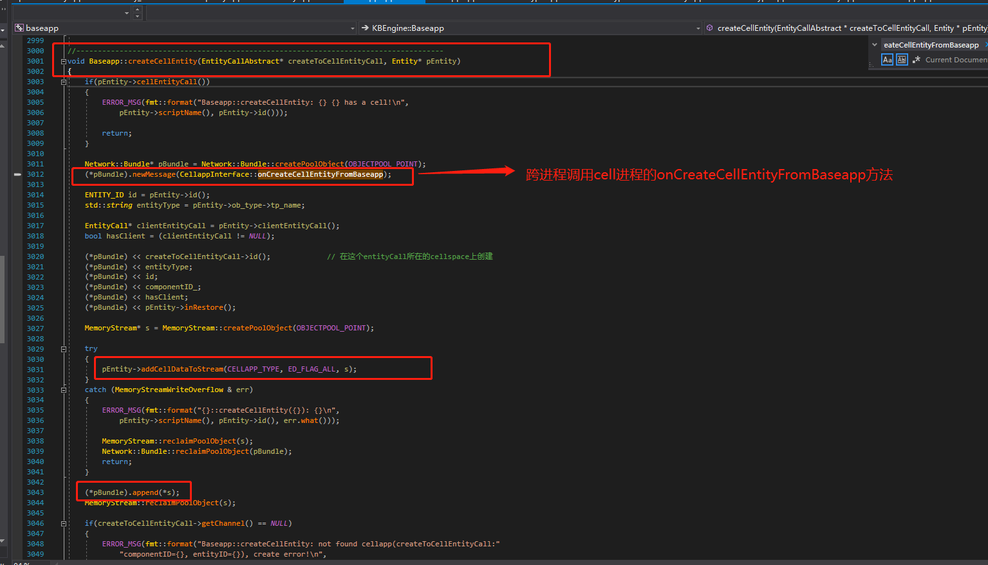

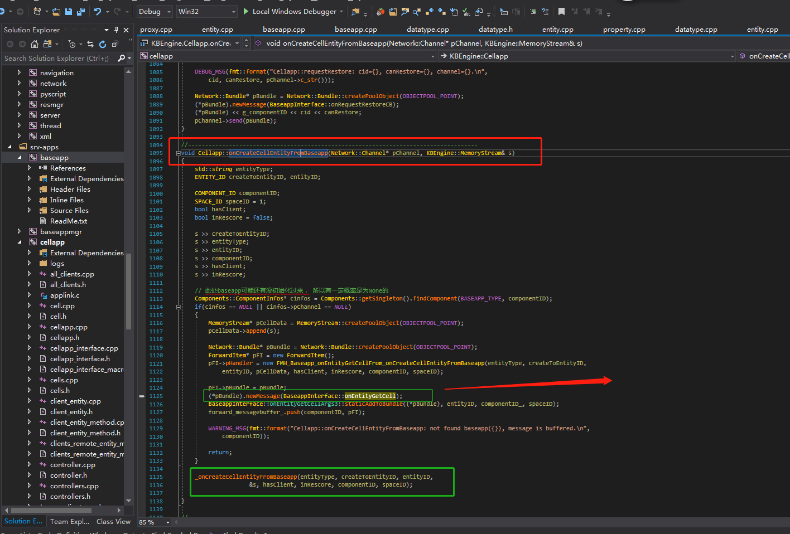

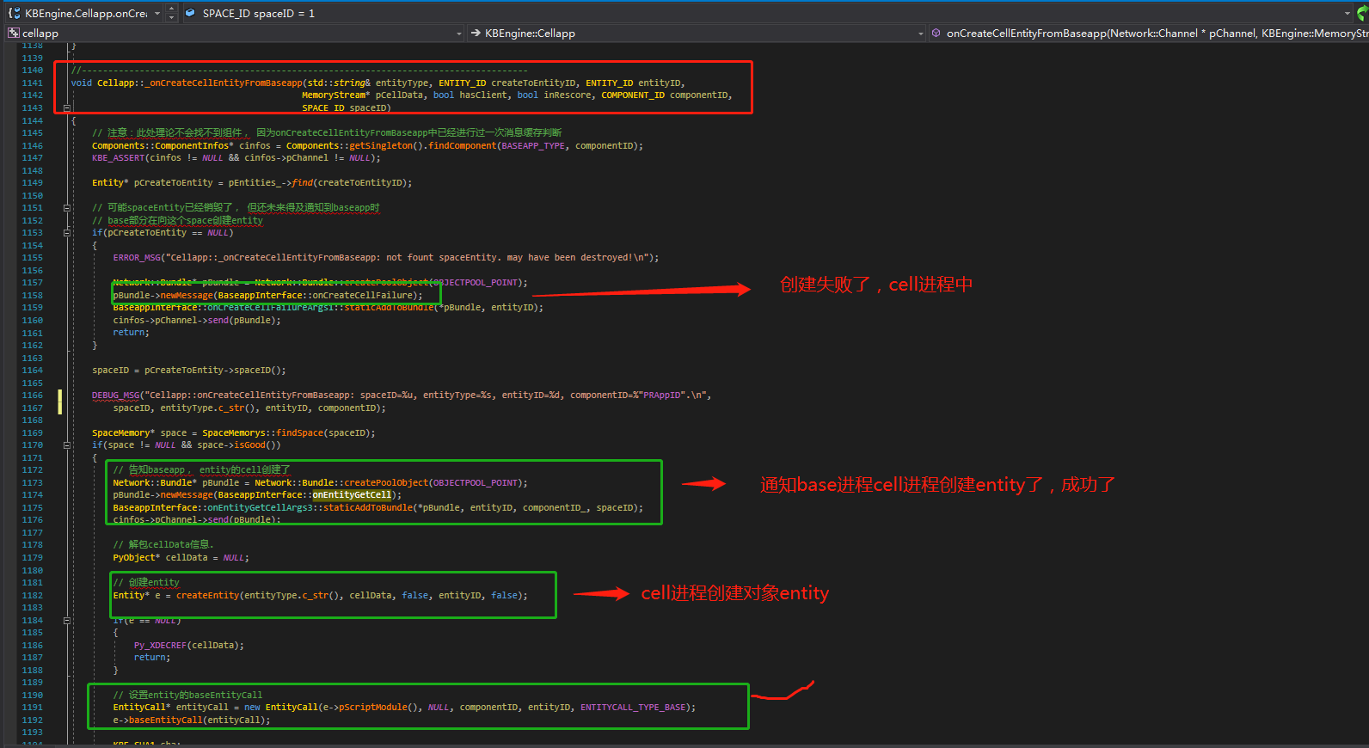

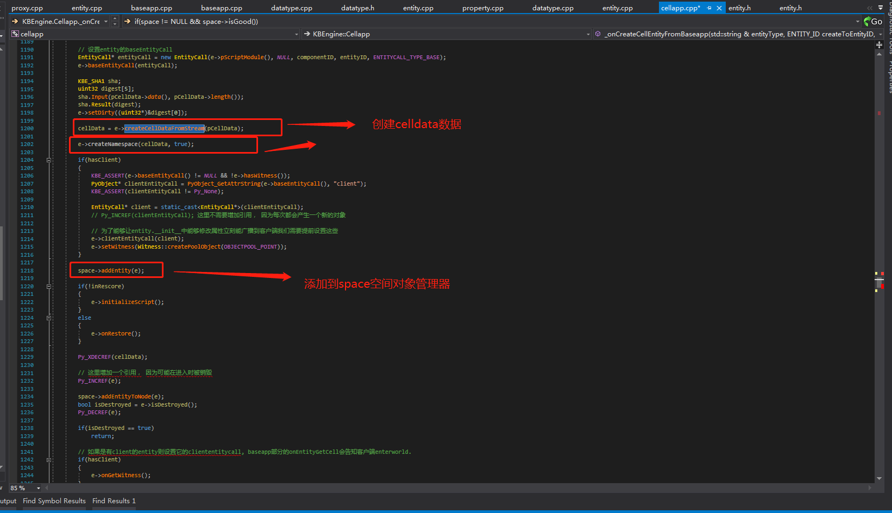

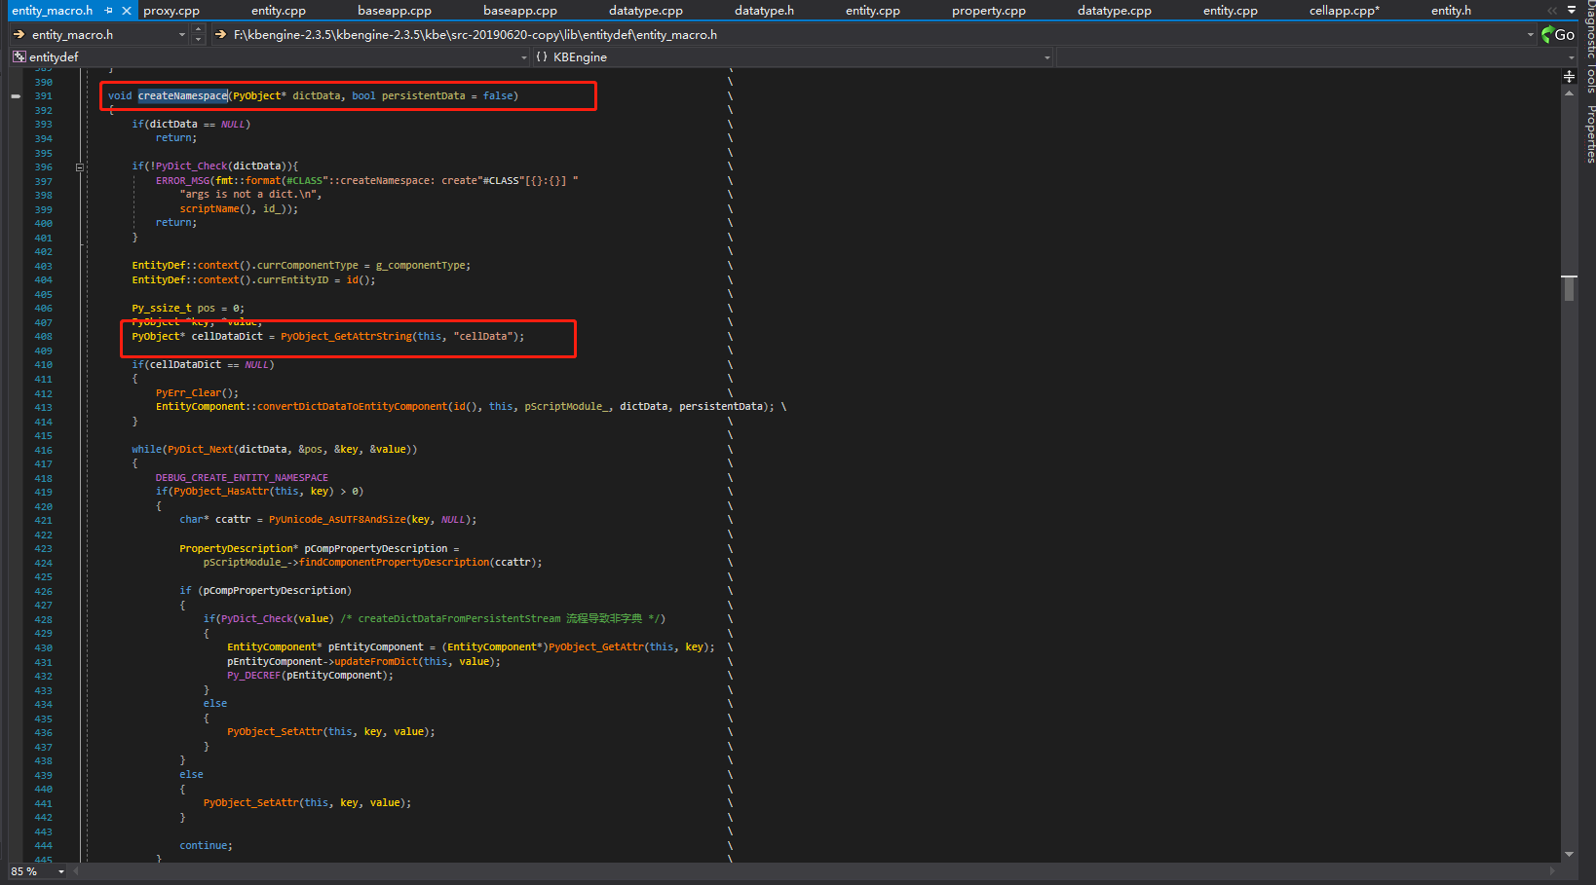

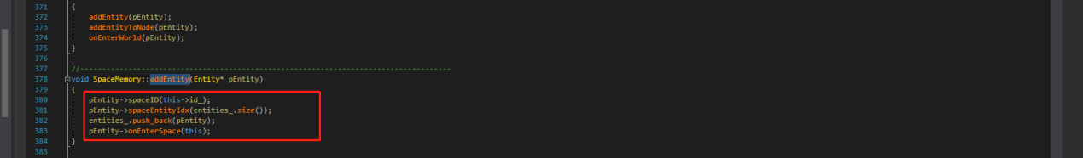

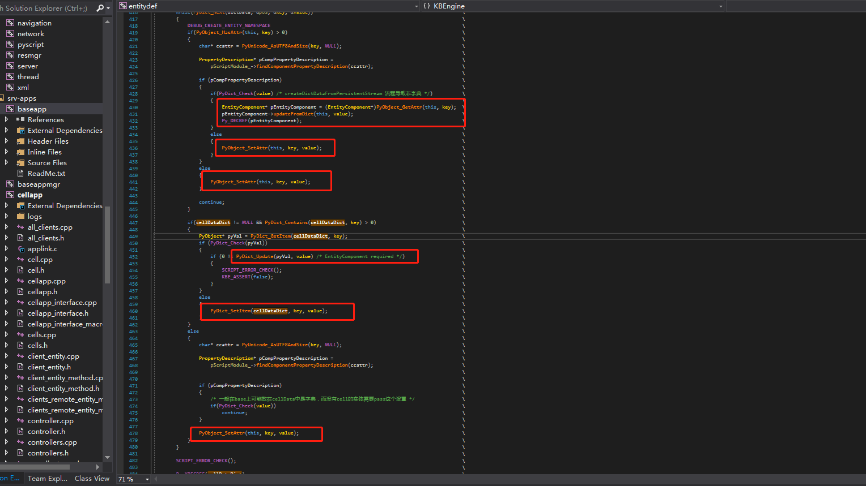

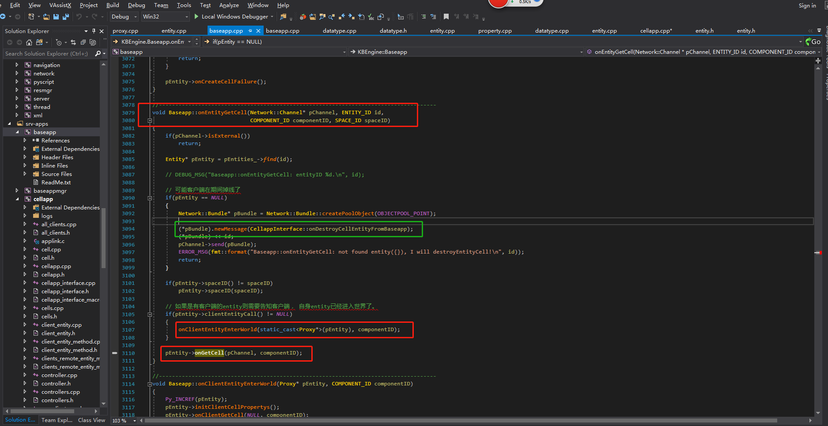

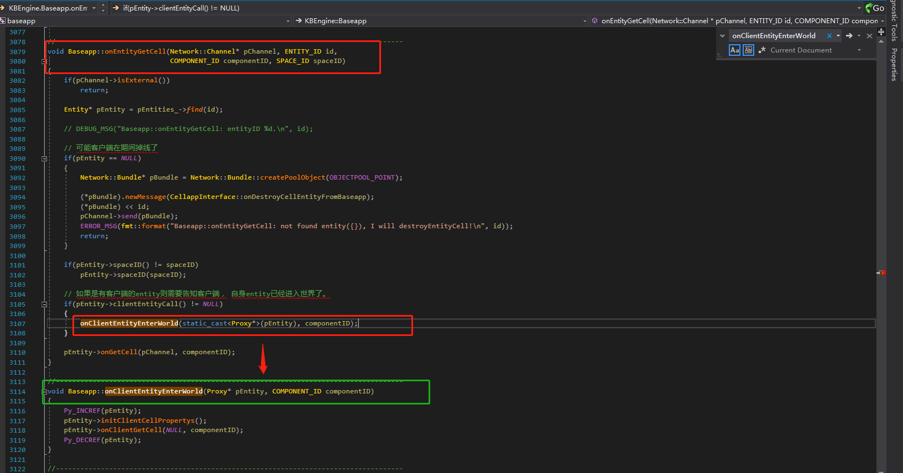

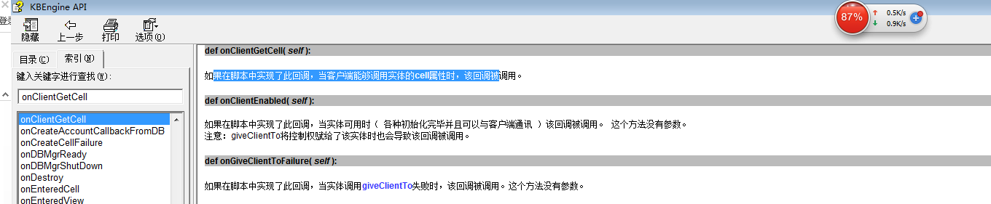

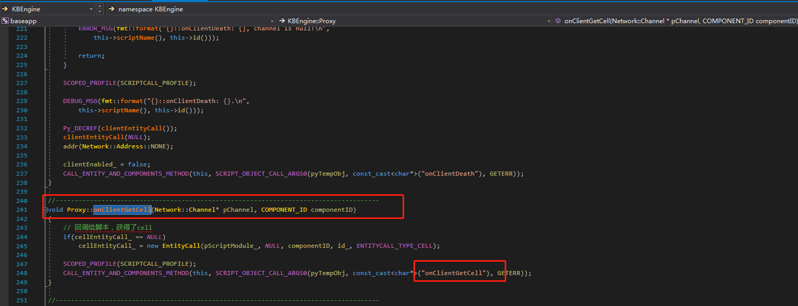

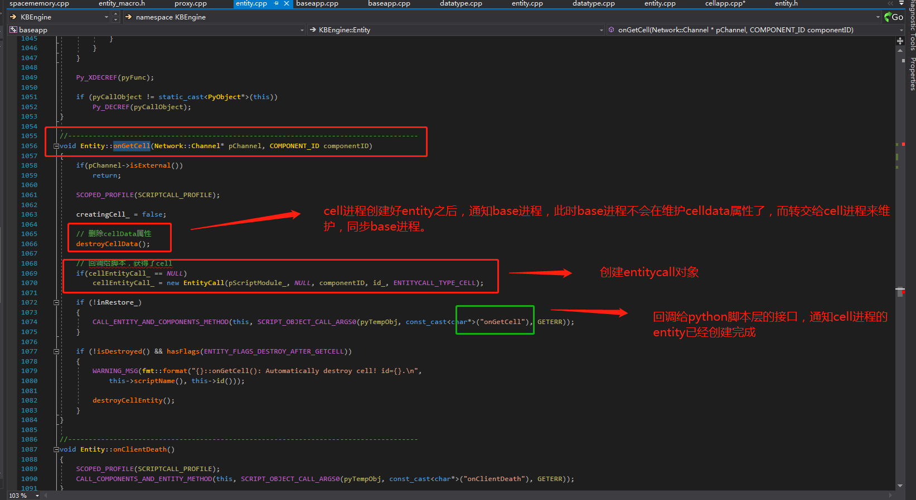

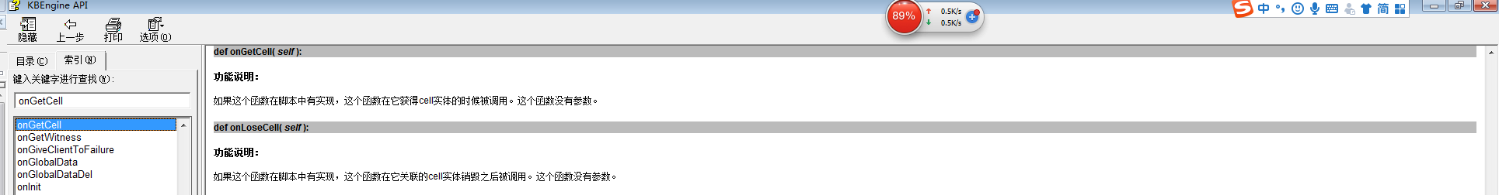

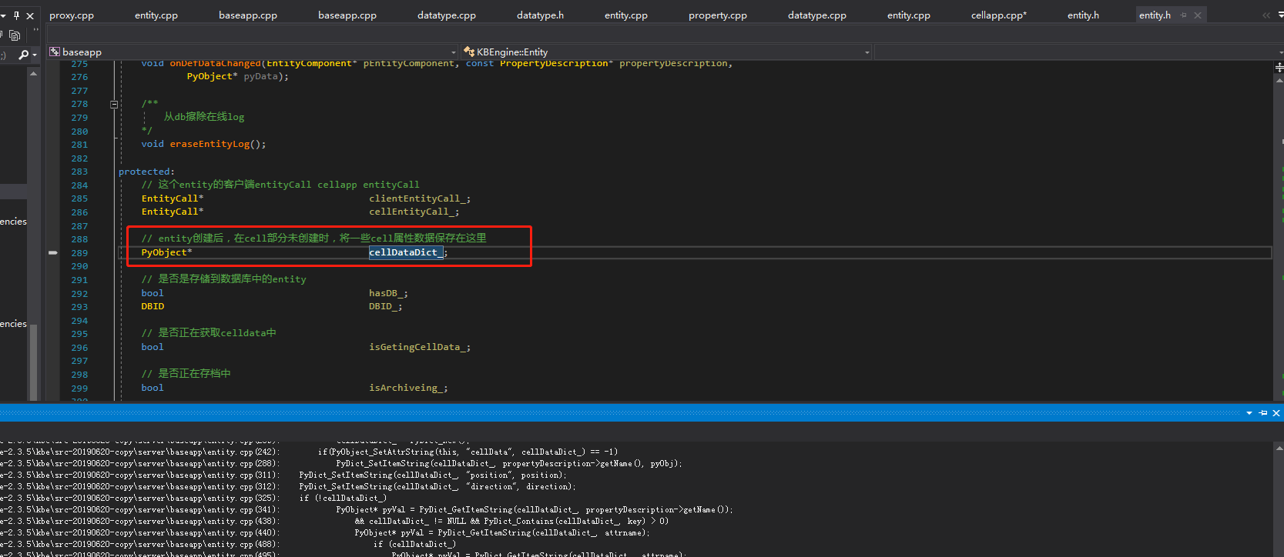

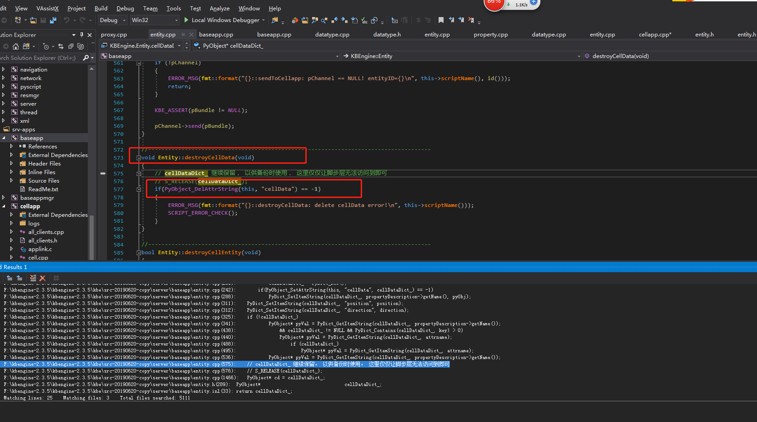

## 全局变量

### g_entityFlagMapping

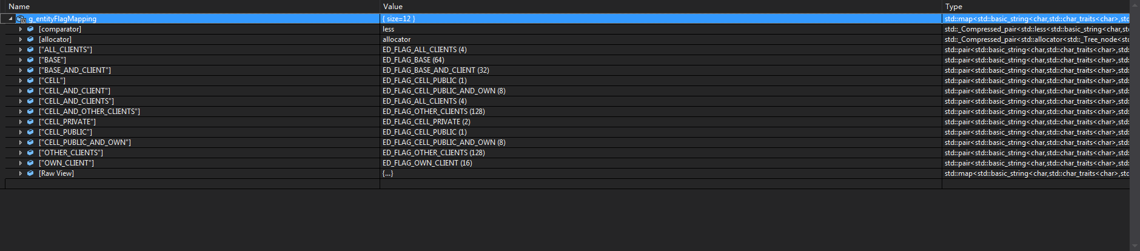

## 引擎类

### Class

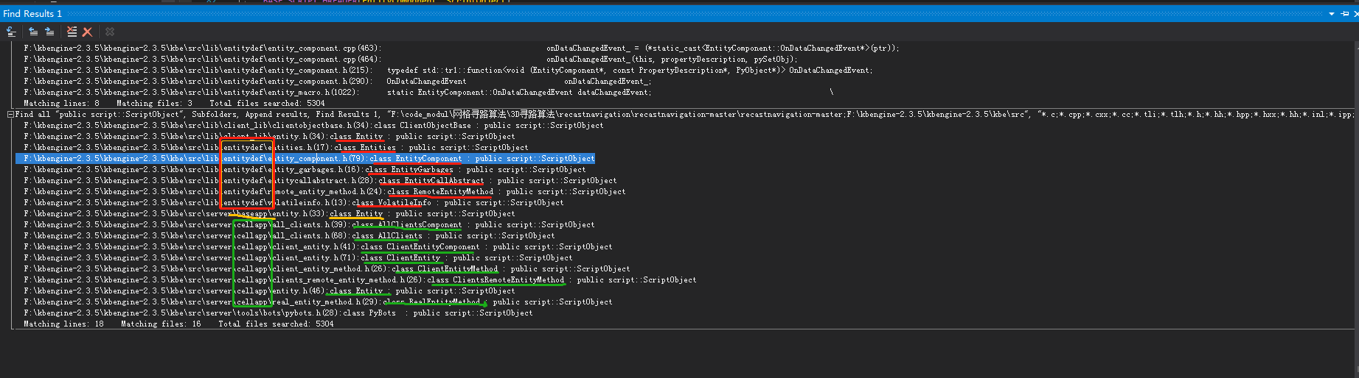

#### EntityDBTask类：数据库相关操作基类和子类

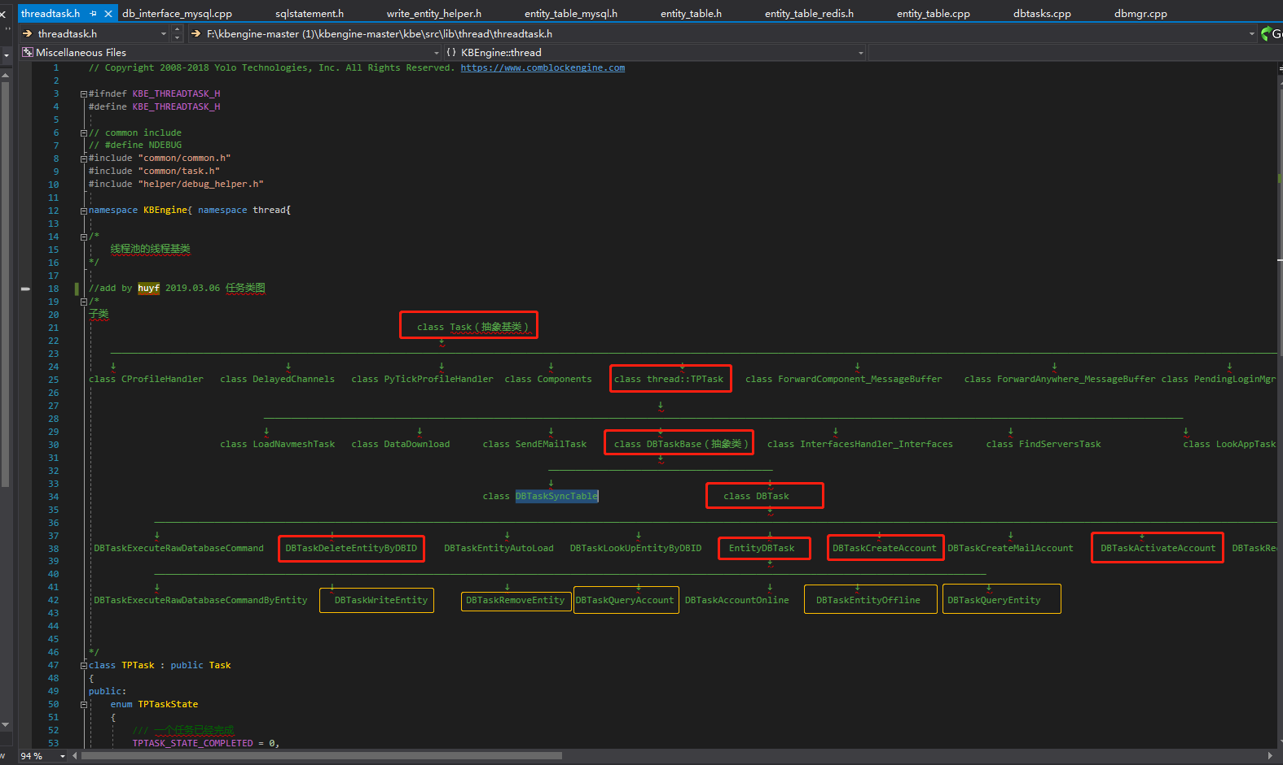

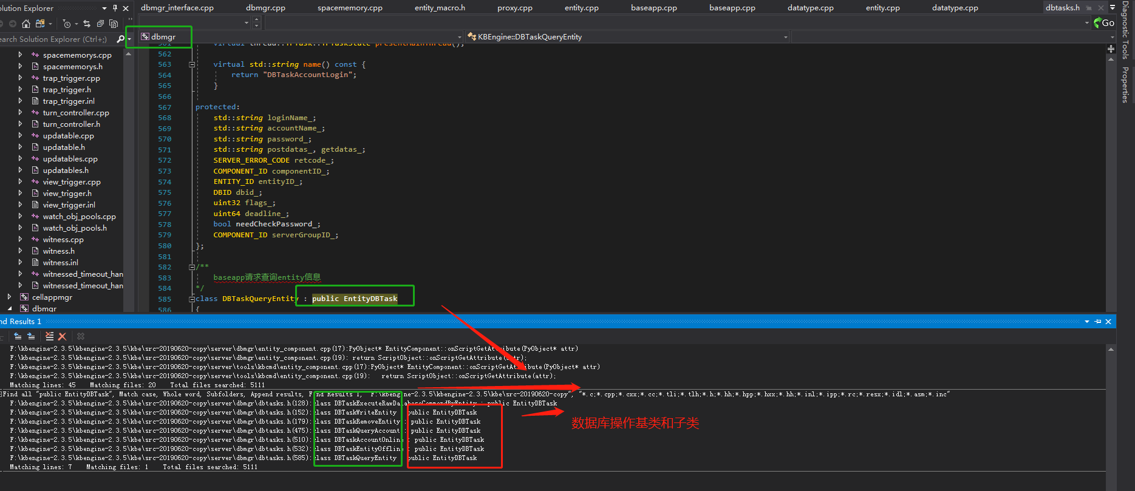

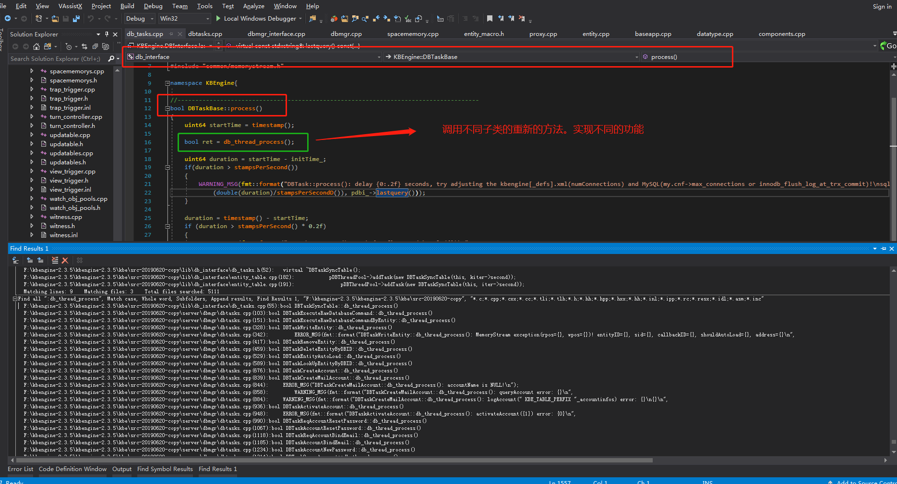

#### WriteEntityHelper-写-数据库操作类

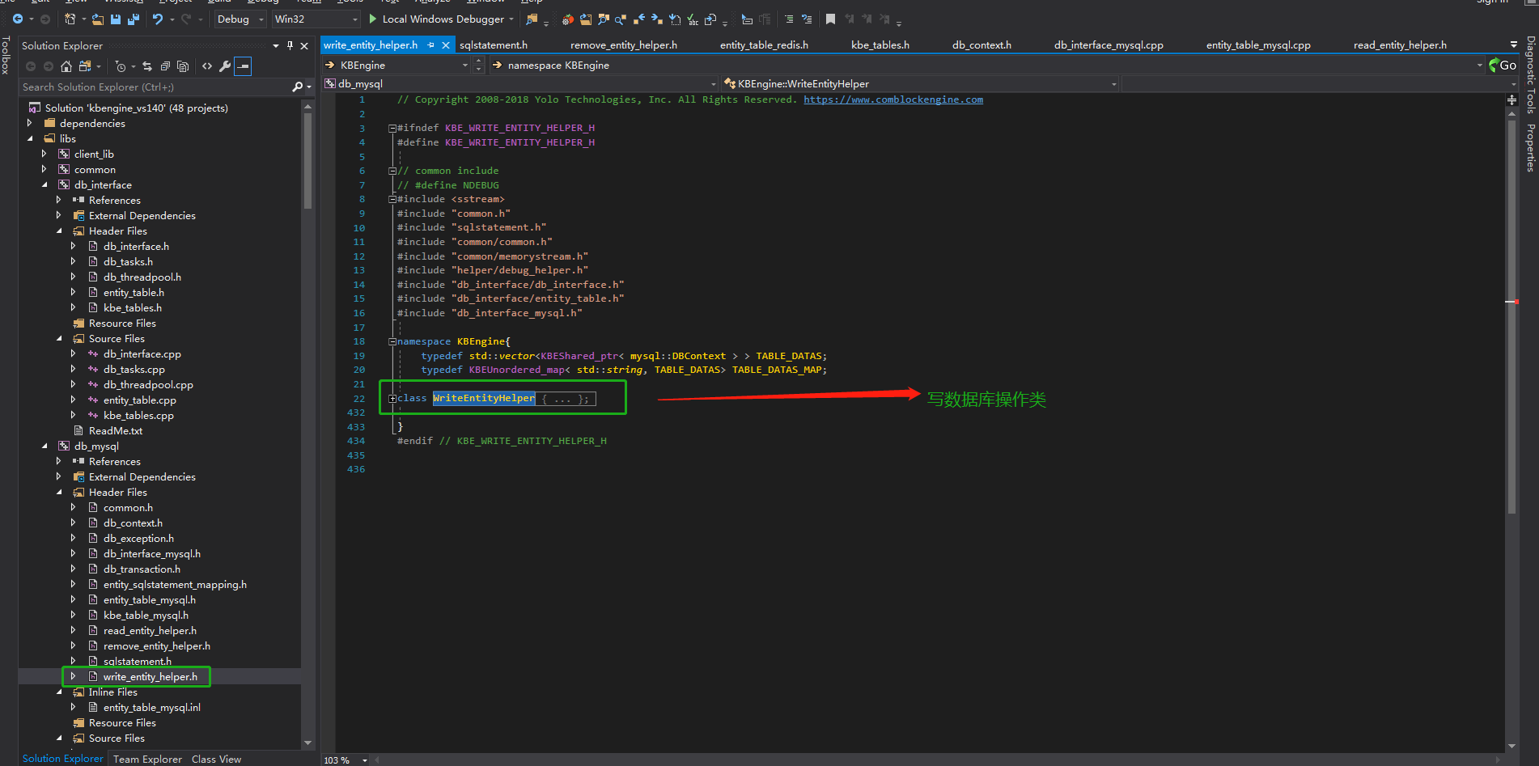

#### ReadEntityHelper-读-数据库操作类

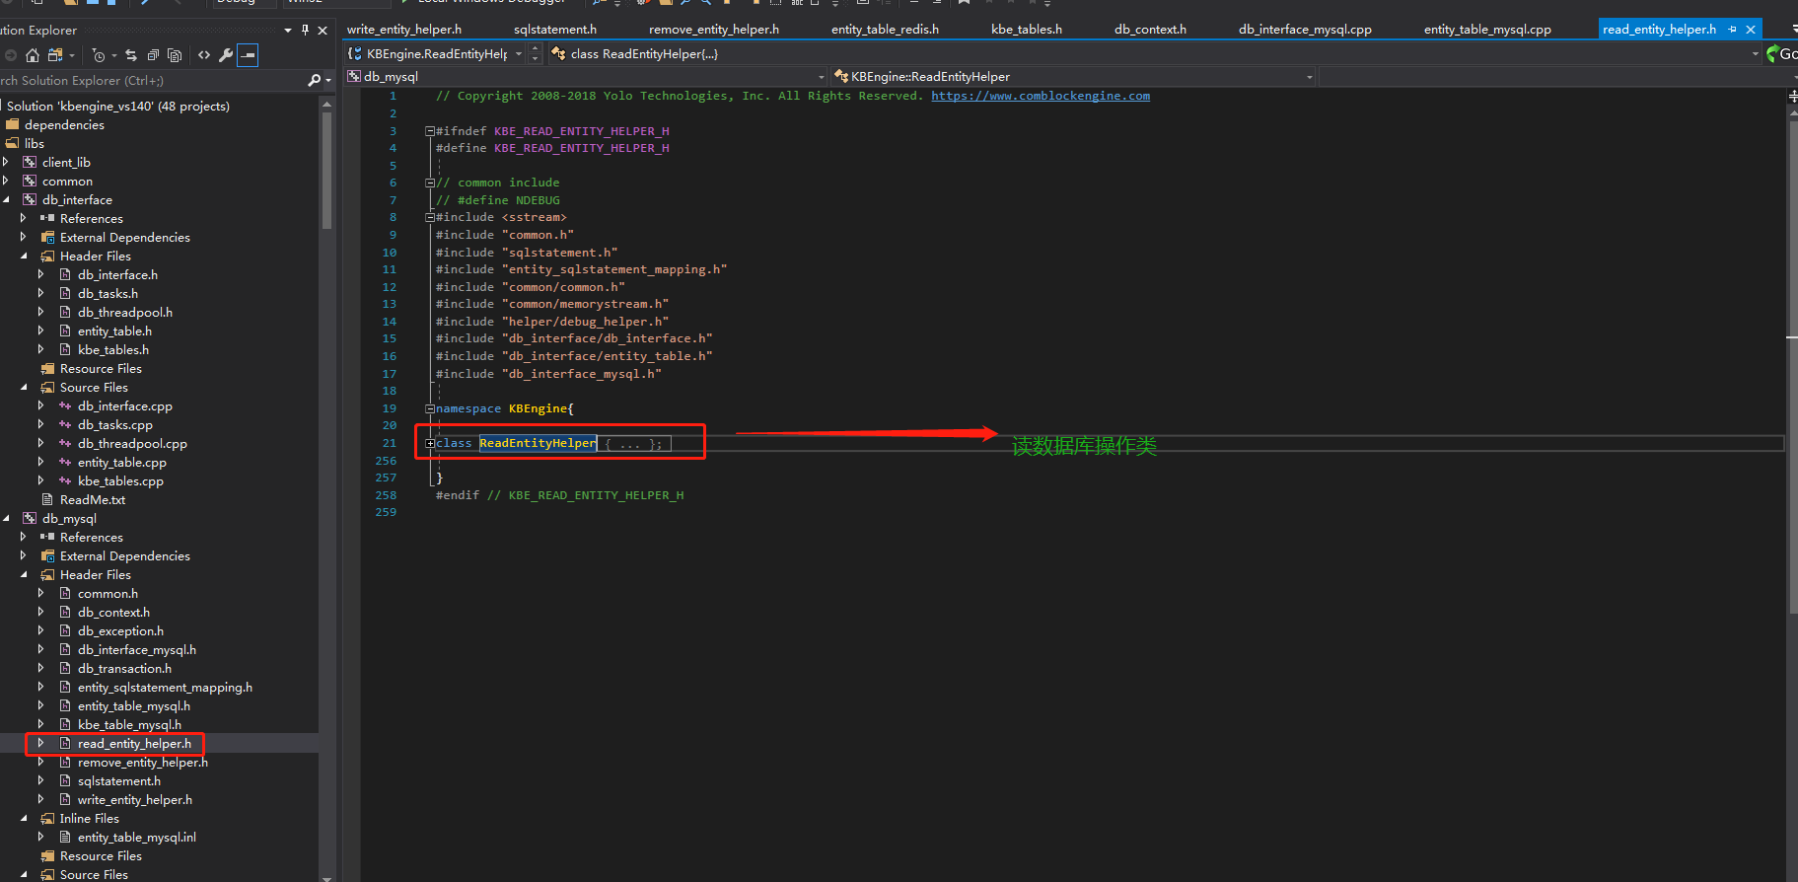

#### RemoveEntityHelper-删除-数据库操作类

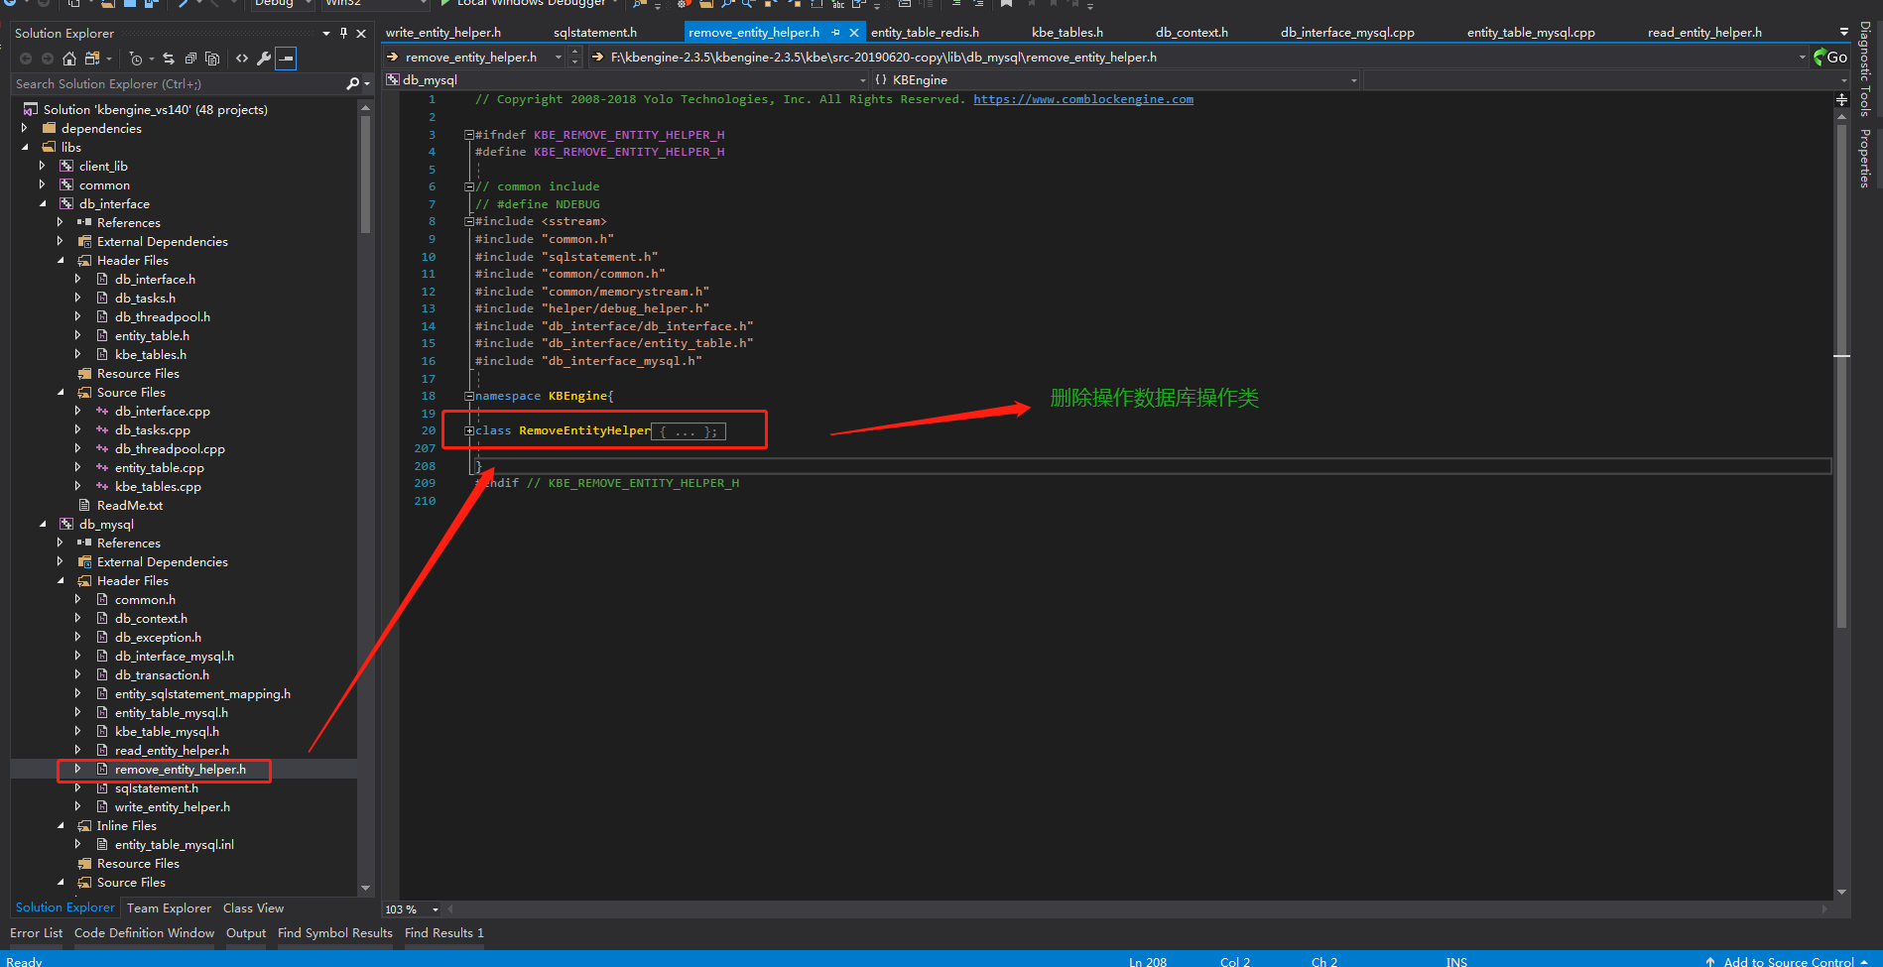

#### SqlStatement类-数据库查询语句相关

##### SqlStatementInsert：插入语句类

##### SqlStatementUpdate：更新语句类

##### SqlStatementQuery：查询语句类

##### 

#### ScriptDefModule类

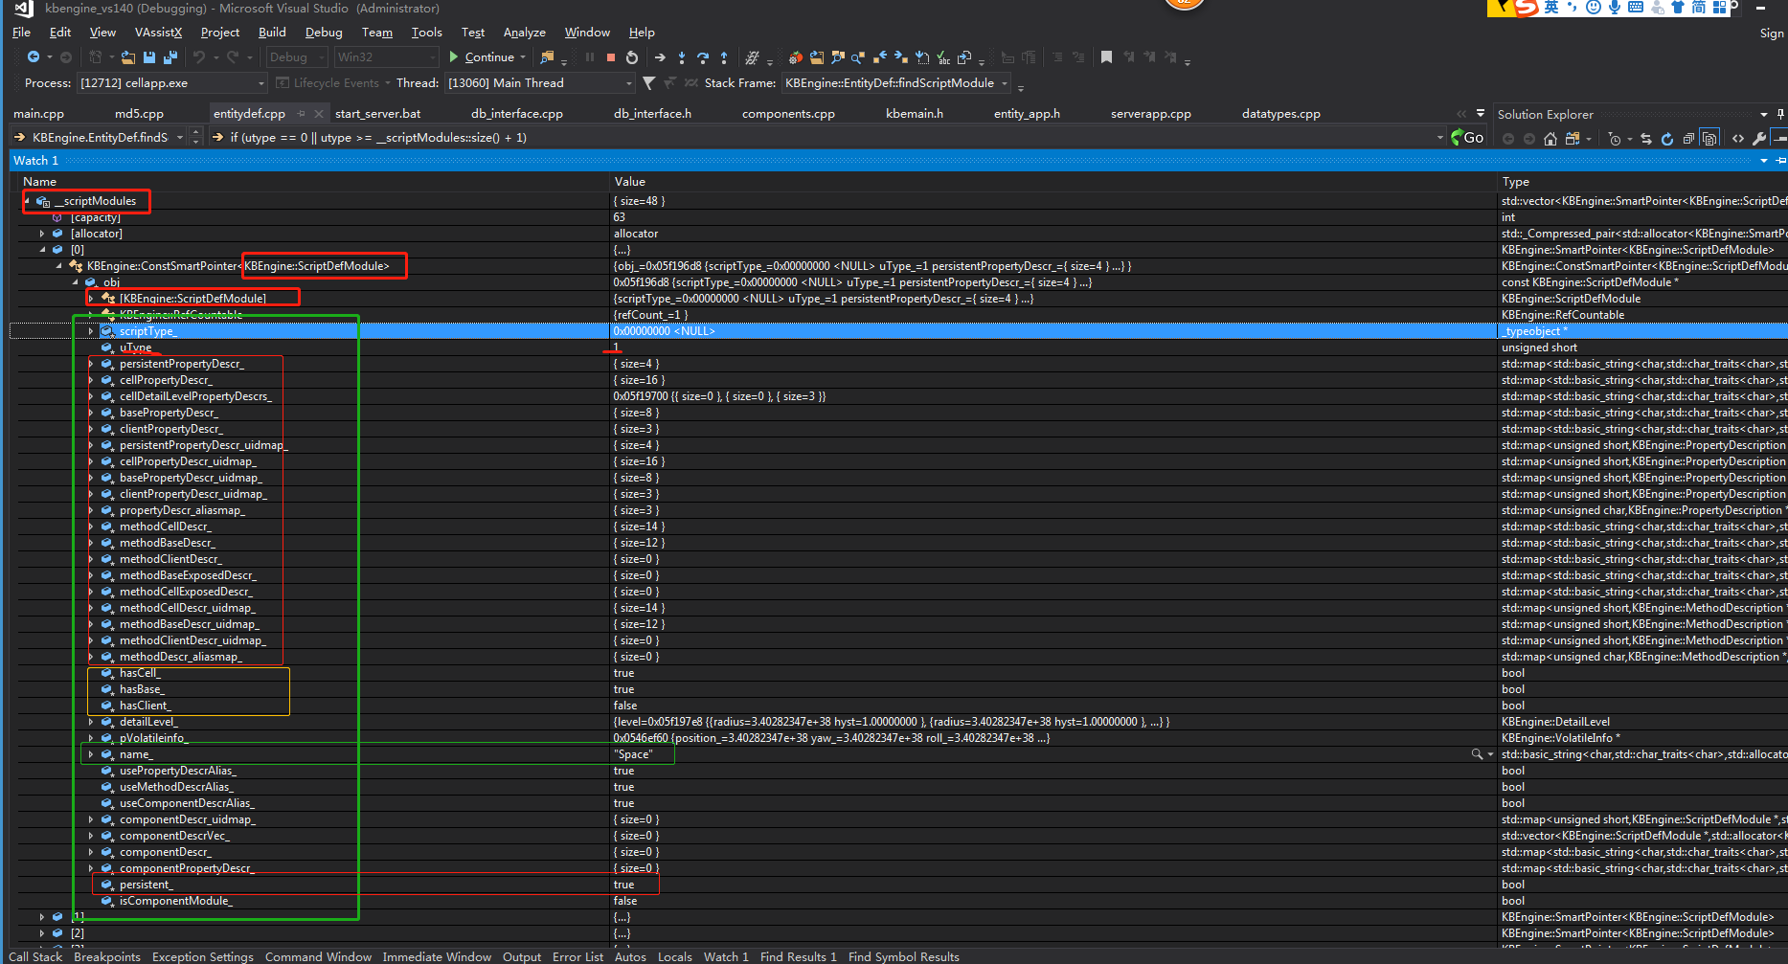

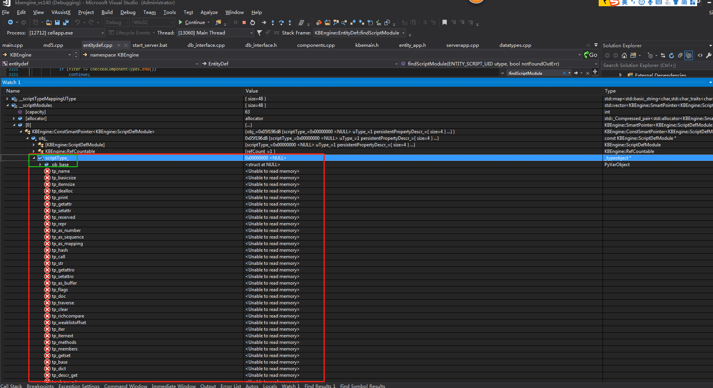

#### ScriptObject类: public PyObject

##### 成员变量

###### dataTypes_

DataTypes::DATATYPE_MAP DataTypes::dataTypes_;

##### 成员方法

DataTypes::DATATYPE_MAP DataTypes::dataTypes_;

/**

脚本请求创建一个该对象

*/

static PyObject* tp_new(PyTypeObject* type, PyObject* args,

PyObject* kwds);

/**

脚本请求获取属性或者方法

*/

###### PyObject* onScriptGetAttribute(PyObject* attr);

/**

脚本请求设置属性或者方法

*/

###### int onScriptSetAttribute(PyObject* attr, PyObject* value);

/**

脚本请求删除一个属性

*/

###### int onScriptDelAttribute(PyObject* attr);

/**

脚本请求初始化

*/

int onScriptInit(PyObject* self, PyObject *args,

PyObject* kwds);

#### EntityComponent类

##### 成员变量

###### dataTypes_

DataTypes::DATATYPE_MAP DataTypes::dataTypes_;

#### DataTypes类

##### 成员变量

###### dataTypes_

DataTypes::DATATYPE_MAP DataTypes::dataTypes_;

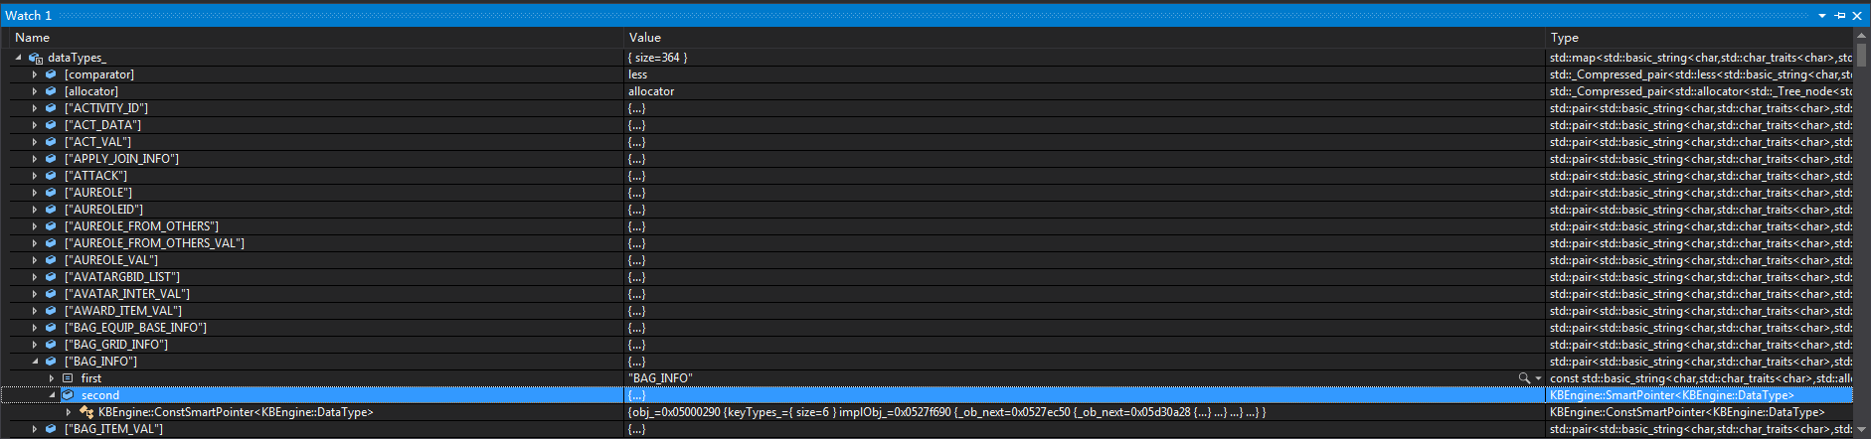

#### ScriptDefModule类

##### 成员变量

###### basePropertyDescr_

// 这个脚本所拥有的属性描述uid映射

typedef std::*map*<std::*string*, PropertyDescription*> PROPERTYDESCRIPTION_MAP;

PROPERTYDESCRIPTION_MAP basePropertyDescr_;

typedef std::*map*<ENTITY_PROPERTY_UID, PropertyDescription*> PROPERTYDESCRIPTION_UIDMAP;

PROPERTYDESCRIPTION_UIDMAP basePropertyDescr_uidmap_;